STATE OF MISSISSIPPI
GROUND WATER QUALITY ASSESSMENT
April 2023

Pursuant to Section 305(b) of the
Clean Water Act

Prepared by the
Mississippi Department of Environmental Quality
Office of Land and Water Resources
P. O. Box 2309
Jackson, Mississippi 39225

TABLE OF CONTENTS

INTRODUCTION ………….…………………………………………………………....... 2

ASSESSMENT OF GROUNDWATER QUALITY …………………………………..... 2

Groundwater Quality Standards

AgChem Program

U.S. Geological Survey

National Water Quality Assessment (NAQWA) Program

Mississippi State Department of Health

Summary of Groundwater Quality

GROUNDWATER CONTAMINATION IN MISSISSIPPI …………………………... 11

Potential Sources of Contamination

Groundwater Assessment and Remediation Efforts

Brownfields Program

Underground Storage Tank (UST) Program

Uncontrolled Sites

Voluntary Evaluation Program

CERCLA Program

RCRA Corrective Action

GROUNDWATER PROTECTION EFFORTS ……………………………………… 19

Wellhead Protection Program

Source Water Assessment Program

Source Water Protection

Source Water Protection Strategy

Source Water Assessment Summary for Public Drinking Surface Water Intakes

Summary of State Groundwater Protection Programs

Investigations Supporting Groundwater Protection

Office of Land and Water Resources

Office of Geology

U.S. Geological Survey

Harrison County Study

Real-Time Monitoring of Water Levels

Groundwater Data and Maps Database

Computer Groundwater Models

Phosphorus in the Mississippi River Alluvial Aquifer

SOURCES FOR WATER SUPPLY IN MISSISSIPPI ……………………………… 32

INTRODUCTION

Section 106(e) of the Clean Water Act requires that each state monitor the quality of its surface and groundwater resources and report the status to Congress every two years in its State 305(b) Report. This section of the 305(b) Report addresses the groundwater quality in Mississippi. Groundwater resources provide over 90% of Mississippi’s drinking water supply (MSU Coop Ext. Jason Barrett 2015). The 1,414 public water systems operating in the state use 2,840 wells and four surface water intakes. Because of this reliance on groundwater, the State has a vested interest in its protection as evidenced in this report.

Over the years, the Environmental Protection Agency (EPA) has revised the reporting requirements associated with the groundwater section of the 305(b) Report. These changes signaled an attempt by the EPA to not only address relevant groundwater issues of concern or interest but also to obtain aquifer-specific data that can be used for comparison sake. There are 16 major aquifers and numerous minor aquifers distributed throughout Mississippi. Unfortunately, this large number of aquifers makes providing aquifer-specific data in the report cumbersome.

The overall quality of the groundwater resources in Mississippi remains very good. Natural coloration associated with certain aquifers is the most notable groundwater quality issue in the state. Extensive contamination of aquifers in the state or incidents of public water systems being impacted by groundwater contamination are uncommon. The sporadic “boil water” notices periodically issued in the state are usually the result of system maintenance issues or unforeseen natural disasters. Another issue is the relatively large number of small rural water associations operating in the state that are often plagued with compliance issues.

ASSESSMENT OF GROUNDWATER QUALITY

EPA guidelines for the 305(b) Report encourage the use of the best available data in reflecting the quality of the groundwater resources. To provide as accurate and representative assessment of the groundwater quality in Mississippi as possible, the information in this report contains data compiled from the Mississippi Department of Environmental Quality (MDEQ), the Mississippi State Department of Health (MSDH), and the U. S. Geological Survey (USGS).

Groundwater Quality Standards

In November 1991, MDEQ adopted groundwater quality standards equivalent to the EPA established drinking water standards or Maximum Contaminant Levels (MCLs). These standards apply to all of the groundwater in Mississippi that meets the EPA’s definition of underground sources of drinking water (USDW), which is defined as water that “contains fewer than 10,000 mg/l total dissolved solids.” However, the State standard did allow for an exemption of certain water-bearing geologic units capable of yielding only extremely low volumes of water.

The standards also establish a procedure to calculate groundwater quality standards for types of constituents that may not be included on the EPA list of MCLs.

Mississippi Agricultural Chemical Groundwater Monitoring Program

The Mississippi Agricultural Chemical Groundwater Monitoring (AgChem) Program was initiated in March 1989 for the purpose of determining if the use of agricultural chemicals is impacting groundwater quality in Mississippi. Thus far, the sampling of over 2,000 wells (Figure 1) throughout the state does not indicate any significant impacts directly attributable to agricultural practices.

During 2022, the AgChem Program collected samples from a total of 59 wells across the state, including 4 drinking water wells and 55 large-capacity irrigation and fish culture wells located in the Mississippi Delta.
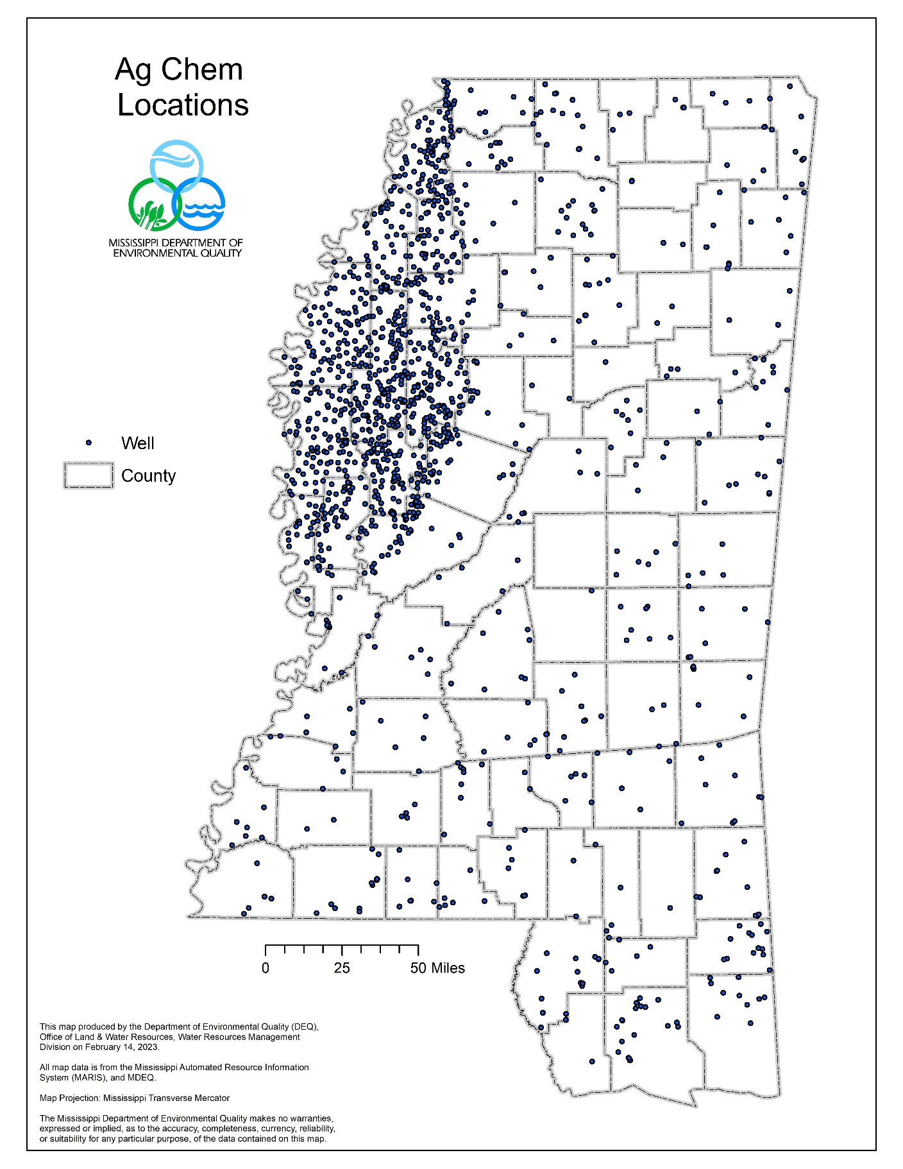
Figure I
Figure 1
U. S. Geological Survey

The USGS has sampled water wells in Mississippi since the early 1900’s. Most of the USGS sampling has involved analysis of inorganic parameters to characterize the basic types of groundwater found in the various aquifers across the state. These sampling efforts helped establish that most of the groundwater in Mississippi can be characterized as a soft sodium or calcium bicarbonate type. Since about 2015, the USGS has been involved in several groundwater-related data collection and investigative studies.

National Water Quality Assessment (NAWQA) Project – Congressional funding in the late 1980s enabled the USGS to initiate the NAWQA Program, designed to investigate the status and trends of the water quality in the streams, rivers, and groundwater supplies found throughout the nation. Sixty study areas (or units) were defined and the USGS began phasing in this project in 1991. Initially, 15 NAWQA study units across the nation were designated for investigation, including one that encompassed parts of six states in the Mississippi Embayment. A significant area of northern Mississippi was contained in this investigation, including the Mississippi Delta region, the preeminent agricultural area in the state. The study involved the sampling of 14 wells in Mississippi pumping from the shallow MRVA, widely used for irrigation and fish culture in the Delta, or various deeper Tertiary aquifers that provide drinking-water supply throughout northern Mississippi. The results reported by the USGS indicate no exceedances of MCLs on any samples obtained from the Tertiary aquifers in the state. The study also concluded that even the shallow alluvial aquifer underlying the Mississippi Delta had not been adversely impacted by the application of significant amounts of pesticides in the region. The reported results from the Mississippi Embayment study closely mimic those reported for MDEQ’s AgChem Program. Cycle II of the NAWQA program began in 2001 and focuses on regional assessments of water-quality conditions and trends.

During Cycle II (2002-2012), three new groundwater investigations began in Mississippi. Three sites were established in the Mississippi Delta region to investigate the fate and transport of agricultural chemicals in surface and groundwater. Two wells were sampled in northwestern Bolivar County in an area used for corn and cotton production. A groundwater infiltration study was conducted in a soybean field in Bolivar County, and a groundwater/surface-water interaction study was conducted in northeastern Washington County adjacent to the Bogue Phalia at US Highway 82.

Two networks sampled during cycle II included wells in MS. Sixteen in the Coastal Lowlands aquifer system were sampled in Hancock, Pearl River, Lamar, Stone, Harrison, Jackson, George, and Perry Counties. An additional 13 wells in the middle Claiborne (Spart) aquifer in Bolivar, Choctaw, Clarke, Coahoma, Issaquena, Leflore, Rankin, Warren, Washington, and Yazoo counties were sampled.

The 60 study units of the NAWQA investigation cover other parts of Mississippi. The Acadian-Pontchartrain study unit is located primarily in Louisiana but covers parts of five counties in southwestern Mississippi. Another study unit focuses on the Mobile River Basin and encompasses a large area along the eastern side of the state associated with the Tombigbee River Basin. Seven wells in Mississippi were sampled during the Mobile River Basin investigation. Reports on the two studies are available online at pubs.er.usgs.gov.

During Cycle III, which began in 2012, wells that were part of several new regional public-supply well networks were sampled in Mississippi as part of Principal Aquifer Survey (PAS) studies. The goal of these networks is to provide nationally consistent data and information on the quality of some of the Nation’s most heavily pumped aquifer used for public supply. Three Principal Aquifers have been sampled in MS, the Coastal Lowlands and Southeastern Coastal Plain in FY 2013 and the Mississippi Embayment in FY 2014. Well selection was determined using an equal area grid and random well selection process. The focus of this study is on the quality of raw water. Results of the sampling will be made publicly available through USGS databases and publications. Owner information and specific well locations are not released to the public. This is not compliance sampling; however well owners will be informed of concentrations exceeding Maximum Contaminant Levels (MCLs). Although many of the constituents sampled do not have MCLs, this information may help to better understand the occurrence of natural and (or) human-related constituents in public supply wells screened within the aquifer systems. In addition, samples will be evaluated for the age of groundwater from your supply well. This information has proven valuable to other purveyors for understanding the groundwater system from which they withdraw supplies. The constituents to be analyzed in each well are listed below (table 1).

In 2019, twenty wells that are part of two long-term trend networks in the Sparta aquifer and the Cretaceous aquifers (Eutaw and McNairy) were sampled for major and trace inorganic constituents, nutrients, fecal indicators, and selected organic compounds. These wells are part of the National trend network and observed trends for selected constituents at the network level are available at https://nawqatrends.wim.usgs.gov/Decadal/ . Results for individual wells are available at https://nwis.waterdata.usgs.gov/ms/nwis/qw .

Table 1. Constituents that are being sampled as part of the Principal Aquifer Survey Networks

Field Measurements | Dissolved oxygen, pH, specific conductance, temperature, alkalinity, turbidity and water levels
Basic Suite | Major inorganics, nutrients, dissolved organic carbon, trace elements
Pesticides | (200+)Pesticides and metabolites
VOCs | (90+) Volatile organic compounds
Pharmaceuticals | Human health pharmaceuticals, hormones
Radionuclides | Radon, radium isotopes (224, 226, 228), polonium-210, lead-210, gross alpha and beta
Microbial Indicators | Total coliform, E. coli bacteria, Enterococci bacteria, Somatic and F-specific coliphage
Age-Dating | Tritium, Helium, SF6, Dissolved Gases,14C and 13C, Oxygen & Deuterium stable isotope ratios

Mississippi State Department of Health

The Safe Drinking Water Act (SDWA) allows States to seek EPA approval or primacy to administer their own Public Water System Supervision (PWSS) Programs, often referred to as the drinking water program. To receive program primacy, the EPA must determine that a State meets certain requirements laid out in the SDWA and complementary regulations. Some of these requirements include the adoption of State drinking water regulations that are at least as stringent as the Federal regulations and a demonstration that a State can enforce the program requirements. Mississippi assumed administration of its PWSS Program in 1974 when the Mississippi State Department of Health’s (MSDH) Bureau of Public Water Supply became the primacy agency. This agency is responsible for ensuring that safe drinking water is provided to the 96% of the state’s population who rely on the 1,414 public water systems (PWSs) and their corresponding 2,840 wells operating in Mississippi (Figures II and III).

The EPA also regulates the frequency with which PWSs monitor their water supply for contaminants and report the corresponding analytical results. PWSs are required to monitor and verify that the levels of contaminants present in their drinking water supply do not exceed established MCLs. In Mississippi, most PWSs submit all of their samples to the MSDH for analysis at the state laboratory. The laboratory annually processes and analyzes over 50,000 water samples submitted for microbiological analysis as well as hundreds of samples for lead and copper, nitrate/nitrite, various inorganic constituents, volatile organic compounds (VOCs), total trihalomethanes (TTHMs), haloacetic acids, and bromates. The overall compliance rate of PWSs
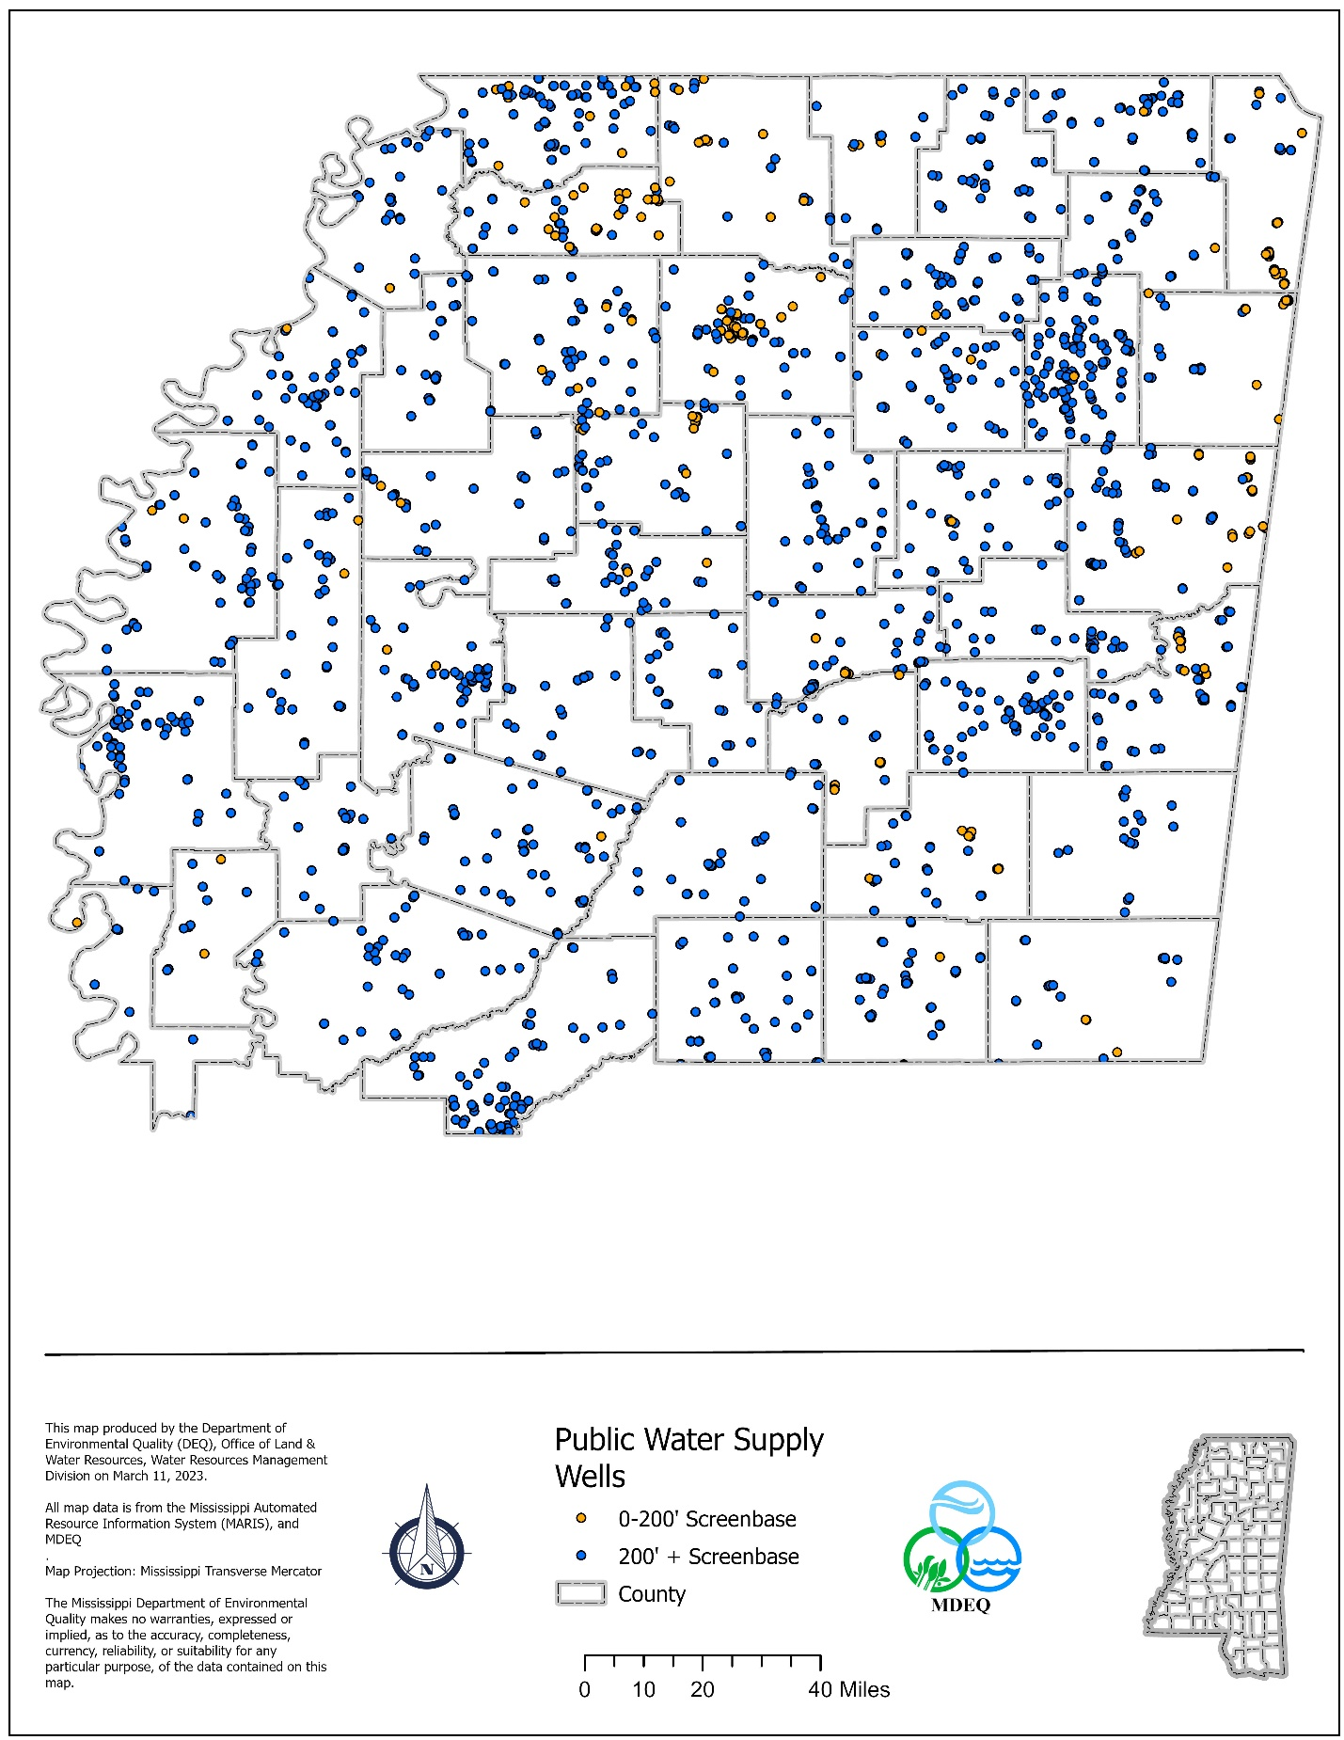
Figure II
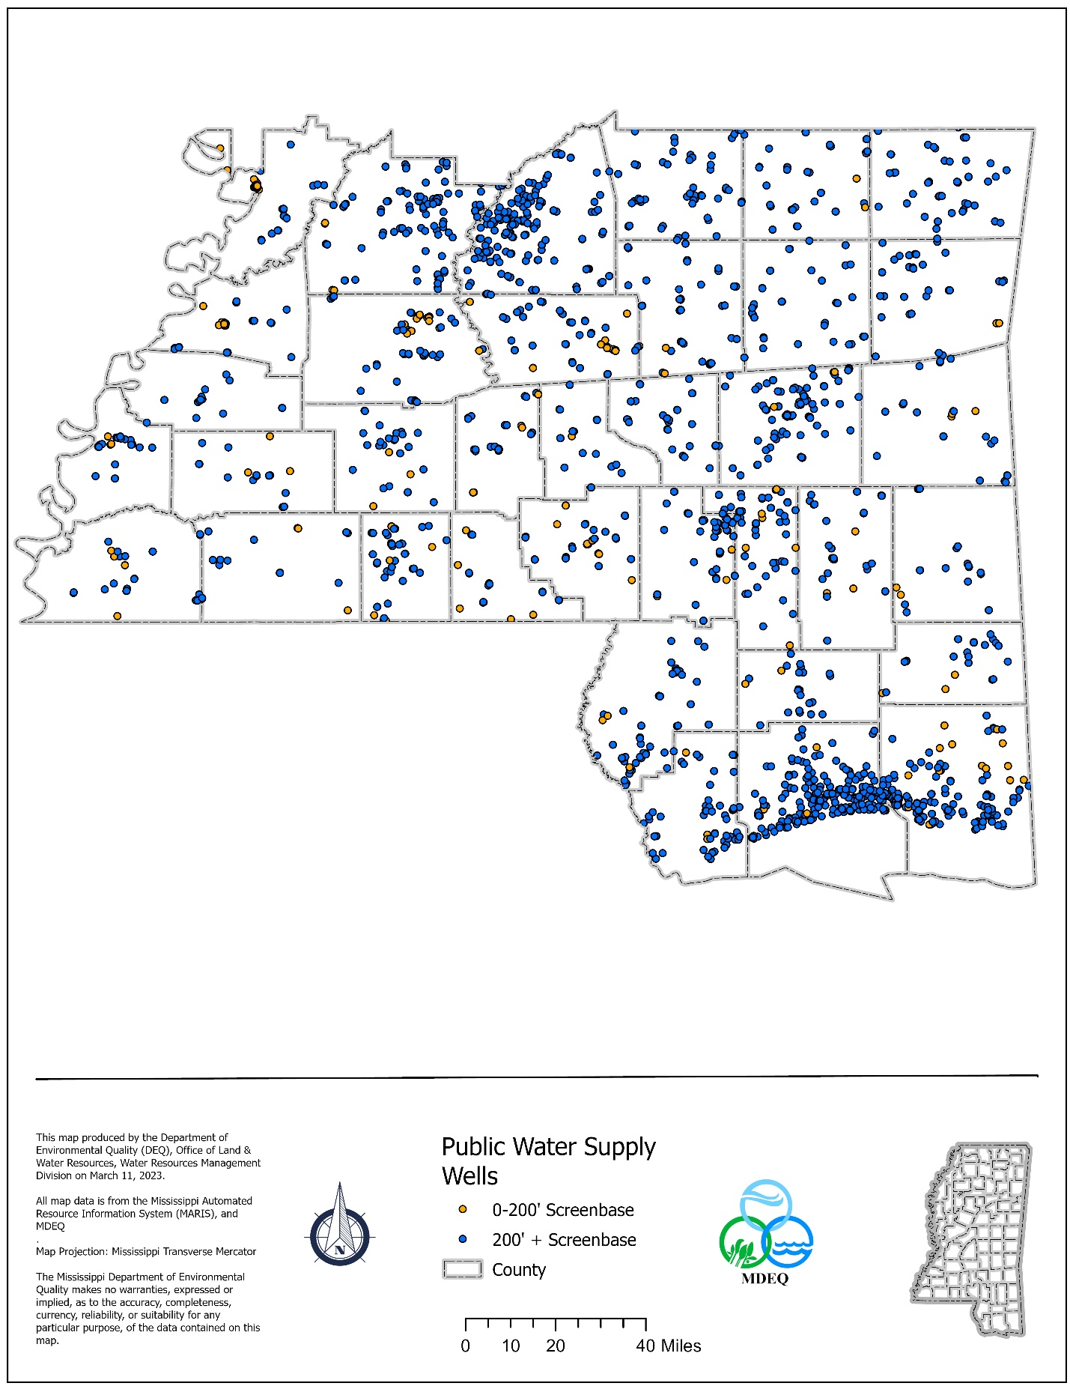
Figure III

in Mississippi is generally very high because of the predominant use of confined aquifers for drinking water supplies. Most of the PWSs have been granted a waiver from monitoring for the synthetic organic compounds (pesticides) based on previous studies, vulnerability assessments, and chemical use data.

Primacy States are required to submit data quarterly to the EPA via the Safe Drinking Water Information System (SDWIS), an automated database maintained by the Federal agency. Some of the data submitted include PWS inventory information, monitoring/compliance information, and enforcement activity related to any system violations. The SDWA also requires States to provide the EPA with an annual report detailing violations of established MCLs by operating PWSs.

The 1996 Amendments to the SDWA require that every community water system provide its customers with a brief annual water quality report. A system’s Consumer Confidence Report (CCR) should explain the nature of any violation, its potential health effects, and the steps being taken to correct the violation. The CCRs often include educational material and also provide information related to the Source Water Assessment Program.

Summary of Groundwater Quality

The information included in Table I summarizes the groundwater quality data compiled by the MDEQ. The reporting period for the MDEQ data is 1990 through 2014. The reported parameters include those specifically requested by the EPA for the 305(b) Report. The only MCL violation for a public water system was for thallium and it is being monitored quarterly.

Table I. MDEQ Analytical Results

Aquifer | # Wells  Sampled | NO3  0-5 mg/l | NO3  5-10 mg/l | NO3  >10 mg/l | VOCs  >MCL | SOCs  >MCL
Miss. River alluvium | 1020 | 1019 | 1 | 0 | 0 | 0
Citronelle | 104 | 101 | 2 | 1 | 0 | 0
Miocene | 224 | 118 | 4 | 2 | 0 | 0
Oligocene | 17 | 14 | 3 | 0 | 0 | 0
Cockfield | 52 | 50 | 1 | 1 | 0 | 0
Sparta | 108 | 108 | 0 | 0 | 0 | 0
Winona-Tallahatta | 34 | 34 | 0 | 0 | 0 | 0
Meridian-Upper Wilcox | 54 | 54 | 0 | 0 | 0 | 0
Wilcox | 79 | 79 | 0 | 0 | 0 | 0
Ripley | 25 | 25 | 0 | 0 | 0 | 0
Coffee Sand | 9 | 9 | 0 | 0 | 0 | 0
Eutaw-McShan | 49 | 47 | 2 | 0 | 0 | 0
Gordo | 20 | 20 | 0 | 0 | 0 | 0
Coker | 0 | 0 | 0 | 0 | 0 | 0
Paleozoic | 5 | 5 | 0 | 0 | 0 | 0

GROUNDWATER CONTAMINATION IN MISSISSIPPI

The aquifers used for drinking water supply in Mississippi generally are confined to some extent by layers of clay that prevent widespread instances of groundwater contamination. Most of the documented cases of groundwater contamination in Mississippi have involved shallow unconfined aquifers that remain widely used in some areas of the state as domestic drinking water sources.

Potential Sources of Contamination

The primary sources of groundwater contamination in Mississippi typically can be traced to leaking underground storage tanks (LUSTs) holding petroleum-based products and faulty septic systems. Another problem of note in areas of the state where petroleum exploration and production have been prevalent is localized brine (saltwater) contamination of shallow aquifers. Many of the past problems associated with the oil and gas industry have been corrected with the adoption of more stringent state regulations. Groundwater contamination involving hazardous waste has been detected at various commercial and industrial facilities across the state as well. These facilities often cover such relatively large tracts of land that the associated contamination plumes are contained within their property boundaries. Table II lists the major sources of groundwater contamination and also other perceived sources of contamination in Mississippi. The location of selected potential contaminant sources such as Brownfields sites, Comprehensive Environmental Response and Compensation, and Liability Act (CERCLA) Program sites, RCRA sites, State sites, and LUST sites are identified in Figures IV and V.

Table II. Major Sources of Ground Water Contamination
Contaminant Source | Ten Highest Priority Sources | Factors Considered in Selecting a Contaminant Source | Contaminants
Agricultural Activities
Agricultural chemical facilities
Animal feedlots
Drainage wells
Fertilizer applications | X |  | Nitrates
Irrigation practices
Pesticide applications | X |  | Various pesticides
Storage and Treatment Activities
Land application
Material stockpiles
Storage tanks (above ground) | X |  | Petroleum products
Storage tanks (underground) | X |  | Petroleum products
Surface impoundments
Waste piles
Waste tailings
Disposal Activities
Deep injection wells
Landfills | X |  | Various constituents
Septic systems | X |  | Nitrates, pathogens
Shallow injection wells
Other
Hazardous waste generators | X |  | Various constituents
Hazardous waste sites | X |  | Various constituents
Industrial facilities | X |  | Various constituents
Material transfer operations
Mining and mine drainage
Pipelines and sewer lines
Salt storage and road salting
Salt water intrusion
Spills
Transportation of materials
Urban runoff
Oil and Gas Production  Exploration/Production  sources (please specify) | X |  | Chlorides
Other sources (please specify)

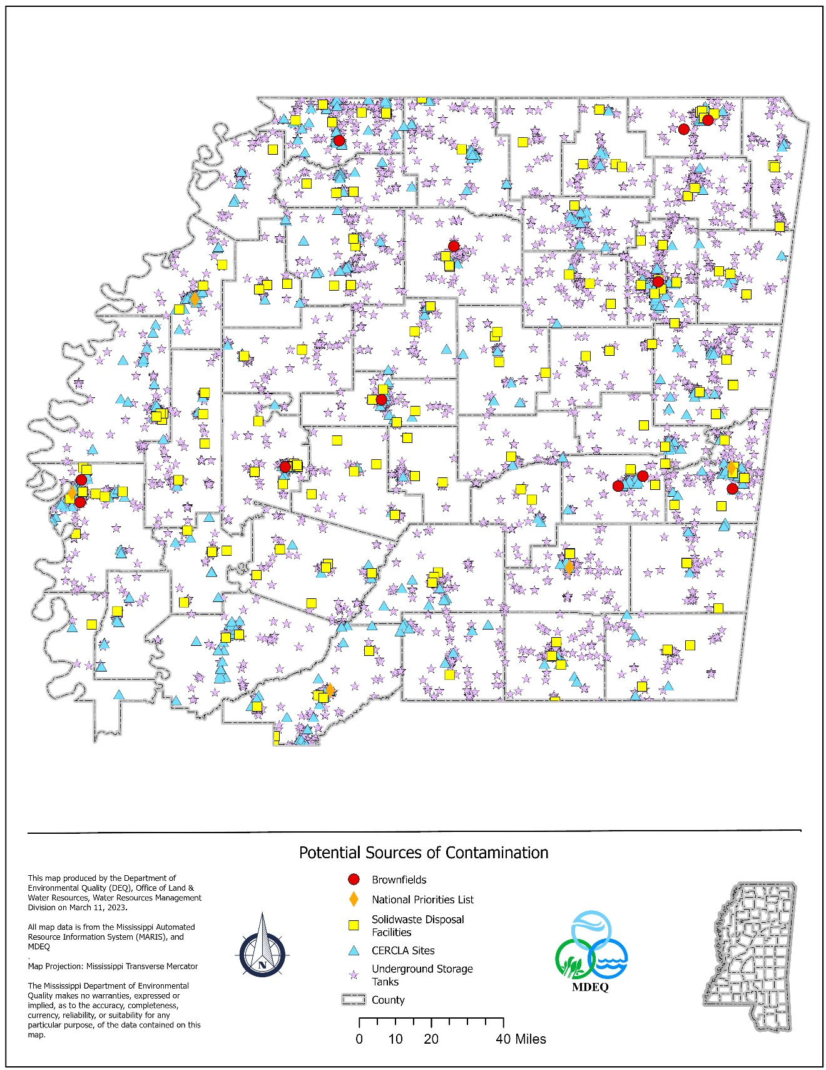
Figure IV
Figure
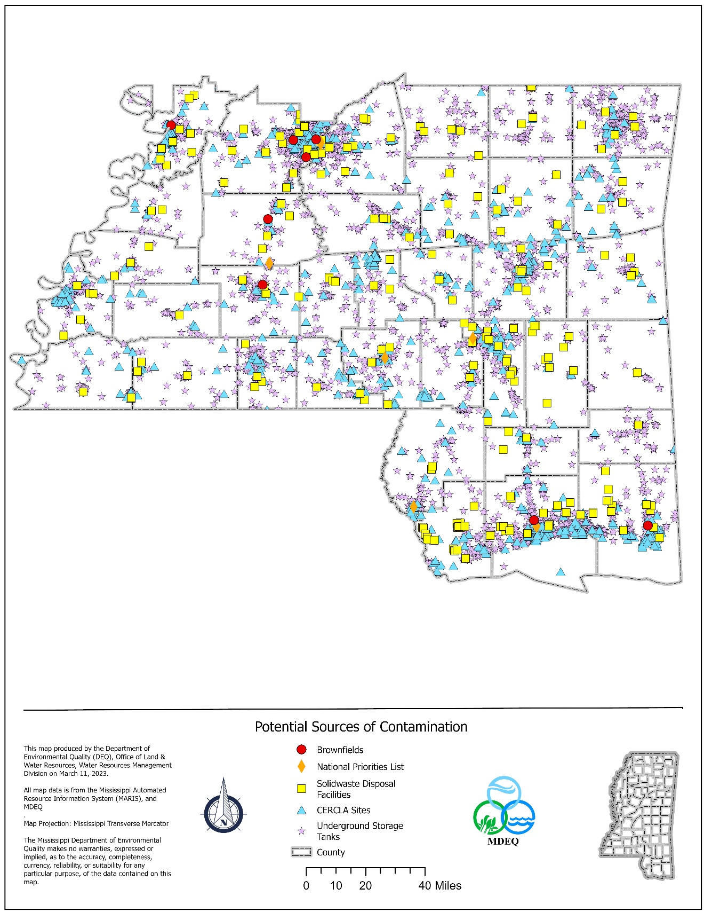
Figure V

Groundwater Assessments and Remediation Efforts

MDEQ learns about contaminated land or water from facility inspections, property transfers, site investigations, complaints, or emergency response activities. Contamination can result from a variety of activities such as improper practices at existing facilities, accidental spills, or leaks from UST systems. MDEQ also gathers information about suspected contamination due to old landfills, illegal dumps, and abandoned commercial or industrial facilities called uncontrolled sites. MDEQ oversees the investigation and remediation of sites that have been or are suspected to have been contaminated by toxic metals, chemicals, petroleum, or other pollutants or contaminants. MDEQ also maintains a database inventory of identified contaminated sites. MDEQ regulates coal and non-coal surface mining activities so as to minimize injurious effects by requiring proper reclamation of surface-mined lands, while balancing the economic necessities of developing our natural resources with protection of the natural environment.

Brownfields
A “brownfield” is real property which may be complicated by the presence of a hazardous substance, pollutant, or contaminant that affects the expansion, redevelopment, or reuse of the property. The MDEQ Brownfield Program is
a multifaceted program that facilitates the re-use of contaminated properties to
viable projects that can bring economic development or provide quality of life
improvements to the community. MDEQ’s Voluntary Brownfield Program allows prospective purchasers and developers, along with existing companies, to assess, remediate, and revitalize brownfield sites. Through the program, companies can coordinate with MDEQ and the Mississippi Development Authority (MDA) to participate in a redevelopment incentive program to defray the remediation costs associated with cleaning up contaminated properties. Since the Brownfield Program was created in 1998, the Mississippi Department of Environmental Quality (MDEQ) has put 700 acres back into productive use (i.e., “Ready for Reuse”). The MDEQ Brownfield Program is a multifaceted program that facilitates the re-use of contaminated properties to viable projects that can bring economic development or provide quality of life improvements to the community. To date, 43 brownfield sites have participated in the program.

During fiscal year 2022, MDEQ provided technical support to the Cities of Canton, Greenville, Hernando, Louisville, Natchez, Vicksburg, and Yazoo City along with the Planning and Development Districts of Golden Triangle, Three Rivers, North Central, and Central to conduct assessments and cleanups for site redevelopment for locations that have potential or perceived environmental issues. These cities and development authorities received EPA grants to conduct brownfield revitalization projects. The agency is working with the recipients to help identify high priority locations for assessments and cleanups with the most potential for redevelopment and beautification of their community.

Underground Storage Tanks
The primary goal of the Underground Storage Tanks (UST) Program is to protect groundwater from leaking underground storage tanks. A two-pronged strategy is used to achieve this goal. First, a compliance program inspects UST facilities in order to ensure the systems do not leak. In Mississippi, the UST compliance personnel are responsible for ensuring approximately 7,883 tanks at 2,953 facilities have the appropriately maintained equipment in order to protect the groundwater. Secondly, in the event of a release, the Mississippi Groundwater Protection fund is used by MDEQ to assess and cleanup any contamination resulting from leaking USTs. The Mississippi Groundwater Protection fund began in 1987 and by June 2022 paid out $225 million to eligible tank owners for the assessment and cleanup of sites contaminated from leaking underground storage tanks. The average fund commitment per site is nearly $175,000. At the end of fiscal year 2022, MDEQ was actively working on 656sites that have had a confirmed or suspected release of petroleum product.

Uncontrolled Sites & Voluntary Evaluation Program

During Fiscal Year 2022, Groundwater Assessment Remediation Division (GARD) staff actively oversaw 227 assessments and/or cleanups with the total number of sites at 2,182. These sites cover all the known and suspected contaminated site reported to the state since 1967. Also, MDEQ issued “No Further Action” letters for eight (8) of these sites that were evaluated and remediated to levels protective of human health and the environment resulting in an additional 444 acres ready for reuse during Fiscal Year 2022.
The Voluntary Evaluation Program (VEP) offers an opportunity to receive an expedited review of site characterization and remediation plans and reports for parties that are voluntarily cleaning up uncontrolled sites that they have an interest in. The VEP is funded entirely by these participants who pay for MDEQ’s oversight costs. To date, 459 sites have participated in the VEP program, approximately 20 percent of GARD’s total number of sites. Through the VEP, more innovative and advanced remediation technologies are recommended and implemented leading to faster, more effective cleanups.

Comprehensive Environmental Response, Compensation, and Liability Act (CERCLA) and Federal Facilities

Oversight of the assessment and remediation process at eight (8) federal Superfund sites, seven (7) Department of Defense Facilities, a NASA Facility (Stennis Space Center) and several Formerly Used Defense Sites (FUDS) continue to be a large portion of the work involving the Comprehensive Environmental Response, Compensation, and Liability Act (CERCLA) Branch of MDEQ. This oversight work is funded through agreements with EPA, the Department of Defense, and NASA. Through these agreements, CERCLA staff perform preliminary assessments, site investigations and site inspections at hazardous waste sites for National Priority List (NPL) consideration, coordinate with EPA on emergency/removal projects, and assist EPA with the oversight of the remediation of seven Superfund sites: American Creosote (Louisville), Kerr-McGee/Tronox (Columbus), Southeastern Wood (Canton), Sonford Products (Flowood), Picayune Wood Treating (Picayune), Mississippi Phosphates (Pascagoula), Hercules (Hattiesburg), and Rockwell International Wheel & Trim/Grenada Manufacturing (Grenada).

RCRA Corrective Action

EPA Region 4 is responsible for 34 sites in the state that are under the jurisdiction of the Resource Conservation and Recovery Act (RCRA) Corrective Action Program. This program covers the cleanup of hazardous waste and hazardous constituents released from Solid Waste Management Units or Areas of Concern at regulated facilities. More than half of these facilities have achieved control of current human exposures and control of the migration of contaminated groundwater according to the EPA website.

Table III is a statewide summary of groundwater contamination source types and the number of sites for each source. The format of the table was established by the EPA, specifically for inclusion in the 305(b) Reports.

Table III. Ground Water Contamination Summary

Hydrogeologic Setting: Statewide
Data Reporting Period: Through June 2022
Source  Type | Number  of Sites | Number of  Sites that  are listed  and/or have  confirmed  releases | Number with  confirmed  ground water  contamination | Contaminants | Number of  Site  Investigations  (optional) | Number  of sites  that have been  stabilized or  have had the  source removed | Number of  sites with  corrective  action plans  (optional) | Number of  sites with  active  remediation  (optional) | Number of  sites with  cleanup  completed  (optional)
NPL | 14 | 9 | 9 | Pentachlorophenol  Creosote  Trichloroethene (TCE) | 13 | 5 | 11 | 6 | 5
CERCLIS  (non-NPL) | 441
DOD/  DOE | 15 | 12 | 8 | VOCs, DRO, TCE, Dioxin, Metals
LUST | 656 | 491 |  | BETX,PAH |  | 290 |  | 73 | 4285
RCRA  Corrective  Action | 34 | 17 |  | VOCs, SVOCs, Metals |  |  |  |  | 17
Underground  Injection | 11-CL I  1539-CL II | 0 | 0
State Sites | 1746 |  | 415 | Metals, VOCs, SVOCs, Pesticides, Herbicides |  |  |  |  | 691
Non-point
Sources
Totals | 4456 | 529 | 432 |  | 13 | 295 | 11 | 79 | 4998
For Underground injection Class II wells, these wells are not regulated by MDEQ. They are regulated by MS State Oil and Gas Board. The Class II wells discussed in this document is in regards to solid waste disposal wells used in the oil & gas industry. These wells are listed as SWD (solid waste disposal) wells at the Oil & Gas Board website. If you do a search for SWD at https://www.ogb.state.ms.us/welldatamenu.php you get the total number of Class II wells

GROUNDWATER PROTECTION EFFORTS

The Mississippi Department of Environmental Quality (MDEQ) has received primacy from the EPA to administer the related Federal programs dealing with groundwater and surface water quality in the state. The Source Water Assessment Branch (SWAB) in MDEQ’s Office of Land and Water Resources (OLWR) has the primary responsibility of coordinating groundwater (quality) protection efforts in Mississippi. Activities to prevent the contamination of drinking-water aquifers in the state have focused mainly on the implementation of the Wellhead Protection Program, completion of Source Water Assessment Program requirements, and addressing Source Water Protection Program related measures.

Wellhead Protection Program

Initial groundwater protection efforts by the Groundwater Planning Branch focused on the State Wellhead Protection Program (WHPP). This program conceptually was designed to identify and properly manage potential contaminant sources in Wellhead Protection Areas from which public water system (PWS) wells capture their water over a specific period of time. Demonstration projects for several high-priority PWSs in Mississippi resulted in the first local management plans being completed in the state by the mid-1990s. MDEQ used the success of these projects to spearhead interest in cross-program coordination of groundwater protection activities in Mississippi.

From the mid-1990s, the Mississippi Rural Water Association utilized a national EPA grant to fund a technician who assisted MDEQ in the development and implementation of local Wellhead Protection management plans. Since 2005 Rural Water has assisted three public suppliers per year with Source Water protection plans using funds under the FSA source water program.

Source Water Assessment Program

The 1996 amendments to the Safe Drinking Water Act mandated states to develop and implement a Source Water Assessment Program (SWAP). The purpose of this program was to notify PWSs and customers regarding the relative susceptibility of their drinking-water supplies to contamination. Congress intended for these susceptibility assessments to encourage efforts that would enhance the protection of PWSs by managing identified potential contaminant sources of concern. In 1998, the Mississippi State Department of Health (MSDH) contracted with MDEQ to develop and administer the SWAP in Mississippi. Required elements of assessments include the following: (1) delineating Source Water Protection Areas around PWS wells; (2) inventorying potential contaminant sources in the protection areas; (3) assigning susceptibility rankings to wells; and (4) notifying the public regarding the availability of SWAP information.

Assessments in Mississippi use the following rankings to notify PWSs of their relative susceptibility: (1) Higher, (2) Moderate, and (3) Lower. Some of the criteria considered when assigning these rankings to public groundwater systems include aquifer confinement; MSDH minimum well design criteria; potential contaminant sources identified within the delineated Source Water Protection Area; and abandoned wells within the protection area.

The size of a Source Water Protection Area is based on eight delineation scenarios that were developed using EPA’s Wellhead Protection Area (WHPA code) computer program. The different scenarios are a result of countless computer modeling runs and an extensive data review of aquifer characteristics and well data from the USGS and MDEQ’s Office of Geology and OLWR. The eight developed delineation scenarios incorporate differing model input parameters, including well discharge, aquifer porosity and transmissivity, aquifer thickness, and time. The approved pumping scenarios are arranged according to well discharge ranges with larger pump rates corresponding to larger Source Water Protection Areas.

Assessments of all public groundwater systems and the four public surface water systems operating in the state have been completed. After MDEQ mailed the prepared assessment reports to the systems, it became their responsibility to notify their customers that a SWAP report was available for review upon request. As another reminder, the EPA required the annual Consumer Confidence Report (CCR) prepared by systems to include a reference regarding the SWAP report and a brief summary of the assessment findings.

The SWAP reports and corresponding maps of delineated Source Water Protection Areas are available online at the MDEQ website: http://landandwater.deq.ms.gov/swap. All new PWS wells now require that preliminary assessments be performed by MDEQ prior to the issuance of groundwater withdrawal permits. These preliminary assessments allow the suitability of proposed well sites to be screened prior to the drilling and completion of PWS wells.

Source Water Protection
The OLWR staff continued its efforts to protect the drinking water supplies of the 1,414 public water systems operating in the state as part of activities related to the Source Water Assessment/Protection Program. This program focuses on the
proper siting of new wells and addressing potential sources of contamination identified in the vicinity of drinking water supplies. MDEQ worked closely with the Mississippi State Department of Health’s Water Supply Division to assist in the
implementation of the EPA’s new Groundwater Rule. MDEQ is also working to identify abandoned public water supply wells so they can be properly plugged by a licensed well driller. Improperly abandoned water wells can serve as potential
conduits for the introduction of contaminants into drinking water aquifers. As of June 2016, 137 wells have been properly plugged and abandoned. This coordinated plugging effort is being funded by the Mississippi State Department of Health.

Source Water Protection Strategy

Mississippi’s Source Water Protection Strategy for PWS wells using unconfined aquifers involves the integration/coordination of protection efforts with various environmental regulatory programs within MDEQ, such as UST, RCRA, CERCLA, and Brownfields/Uncontrolled Sites, as well as the MSDH. The implementation of this strategy is initiated when the corresponding regulatory programs are provided a Source Water Assessment analysis of a PWS well from the Source Water Assessment Branch. This direct cross-program involvement should help to ensure contaminant plumes do not degrade shallow groundwater sources used for public water supply.

The protection strategy for public groundwater systems using deeper confined wells focuses on the hydrogeolologic confinement (vulnerability) of their production aquifers. Adequate aquifer confinement is generally assumed if an overlying confining unit of clay is at least 30 feet in thickness and/or the corresponding potentiometric surface (head) extends at least 10 feet above the screened aquifer. The implementation of this strategy is considered complete when the confinement is verified and a system is notified of any abandoned (unplugged) wells that may pose public health issues.

The Source Water Protection Strategy for the four surface water intakes used in the state involves the integration of public drinking-water protection into MDEQ’s Basin Management Approach that is designed to protect and restore the quality of Mississippi’s surface water resources. This integration component was well received by the Basin Management Managers which incorporated extra protection measures into their management plans to complete the strategy.

Source Water Assessment Summary for Public Drinking Surface Water Intakes

The Safe Drinking Water Act (SDWA) Amendments of 1996 (Public Law 104-182) required the state to develop and implement a Source Water Assessment Program (SWAP) and to prepare a Source Water Assessment (SWA) for each of the 4 surface water intakes in the state and the 3,892 water well groundwater intakes. All have been completed except the City of Corinth surface water intake. This summary of Source Water Assessment activities just addresses the surface water assessments. In 1998, the MS Department of Health (MSDH) who has federal primacy for the Safe Drinking Water Act (SDWA) contracted with MDEQ to develop and administer the MS Source Water Assessment Program. EPA approved the MDEQ state plan in November 1999. Tennessee Valley Authority (TVA) was contracted to complete the assessment for the City of Jackson intakes at the Ross Barnett Reservoir and the Pearl River (2004) and it was updated by FTN Associates in 2010 , the City of Tupelo intake at the Old Tombigbee River intake at Fulton (2004) and the Short Coleman water intake at Yellow Creek Pickwick Lake (2004) and was updated by TVA in 2008 and 2011. The following is a summary of assessment and protection efforts at the aforementioned intakes. In addition to the SWAP federal requirement the MSDH administers the federal Vulnerability Assessment and the Emergency Response Plan for public water systems in the state which is the first line of defense against terrorism and natural disasters. The SWAP susceptibility analysis for these surface water intakes is based on the following criteria: 1. MSDH water quality analysis, 2. Intake located in stream versus a lake or reservoir, 3. Intake located in Clean Water Act 303(d) list of impaired waters, 4. Intake located in transportation corridors such as barge traffic, railroads, highways and pipelines, 5. Potential contaminant sources located within 1000 foot buffer area of the primary protection area, 6. Potential contaminant source storage or operating concerns and 7. Non-point sources of pollution in the 250 foot buffer of the secondary protection area. All of the surface water intakes for public water consumption are ranked higher due to being located in transportation corridors. The susceptibility rankings which are lower, moderate or higher do not indicate the water supply is safe or un-safe but allows the state to focus resources on protection efforts. The primary protection area is based on a 24 hour time of travel and the entire surface area of the lake or reservoir with a 1000 foot buffer from the water’s edge. The secondary protection area, consist of the upstream sub-watersheds and have a 250 foot buffer. MDEQ administers Section 314 of the Clean Water Act which dictates surface water quality standards based on designated uses such as drinking water, contact recreation (swimming) or aquatic life support (fishing). MSDH administers the SDWA to insure national health based standards are met for public consumption. The numeric value standards can differ between these programs because the toxicity is so different between humans and aquatic species. Some common denominators are nutrients (nitrogen and phosphorous) which lead to algal blooms causing water treatment problems, pathogens from human or animal feces (cryptosporidium, fecal coliform-E. coli, giardia lamblia, legionella and viruses). Nitrates, some pesticides/herbicides and endocrine disrupting chemicals are not removed by conventional water treatment and have to be removed with expensive reverse osmosis treatment. USGS testing of all three of the surface water systems, before and after treatment, for 137 pesticide and pesticide metabolites indicated that none were in violation of the SDWA standards (if a standard was available). Only nineteen of these compounds are regulated under the SDWA. The Clean Water Act and the Safe Drinking Water Act must act synergistically to meet drinking water health based standards. The Basin Management Coordinators have provided oversight for the SWAP updates, financial resources for projects and have integrated SWAP into the Basin Management Approach. EPA has supported workshops and approved projects for Source Water Protection and on a national level is working on integrating some aspects of the SDWA and CWA. There are over 90 SDWA primary enforceable standards and 15 non-enforceable secondary standards that must be tested for and reported to the water consumer each year in the form of a Consumer Confidence Report.

Source Water Protection Plan for the O.B. Curtis Drinking Water Intake FTN 2011 Ross Barnett Reservoir

The Ross Barnett Reservoir is a 33,000 acre impoundment and the upstream drainage area is approximately 3,050 square miles. This is the source of the public water intake for the City of Jackson which serves a population of 175,938. The Primary Protection Area (PPA) includes the surface area of the Reservoir at flood stage (299 ft.) and the 24 hour travel zone in the reservoir upstream from the intake. A 1000 foot protection buffer around the reservoir is also part of the (PPA). The Secondary Protection Area (SPA) consist of the upstream subwatersheds and a 250 foot protection buffer exist from the tributary channel. Some water bodies in the watershed are impaired and 29 TMDLs have been calculated for these and recommend reductions in pollutant loads. Although TMDL reports exist for tributaries of the Reservoir, they are not considered a significant threat to water quality. In many cases, the presence of pollutants in these tributaries has not been substantiated with monitoring data. Pollutants are potentially present based on anecdotal evidence or biological monitoring. Attenuation occurs in these upper reaches and ongoing monitoring by the water treatment plant confirms that upstream pollutants are not present in the treated water in amounts exceeding the National Primary Drinking Water Regulations. Three of these tributaries are located in the Primary Protection Area and are addressed in the 2011 FTN report. The Reservoir is not included on the 303(d) list as impaired and is meeting water quality standards for aquatic life support. The drinking water goals of the Water Quality Monitoring Plan are to track water quality constituents related to drinking water treatment issues identified by the City of Jackson and to assess the status and trends of suspended sediments, dissolved oxygen, algae, and total organic carbon (TOC). When TOC is high the chlorination process can cause four disinfection byproducts to form that are regulated. Lab test are performed on intake water (source water), raw water at the treatment plant and finished water after treatment. Required water quality monitoring is as follows: continuous monitoring for turbidity, monthly for chlorite, total organic carbon (TOC) and bacteria, quarterly for disinfection by-products, yearly for cyanide, inorganic chemicals, and nitrate, every three years for lead, copper and synthetic organic chemicals, and every six years for volatile organic chemicals and radionuclides. The treatment process consist of pre-oxidation (to address taste, odor, manganese removal and pH adjustments), flocculation, ultraviolet disinfection and ultrafiltration to achieve a 99.99% reduction in biological contaminants. The ultrafiltration process also reduces the risk for cryptosporidium in the finished water. Samples of raw water and finished water were tested for 137 pesticide and pesticide metabolites and all were below EPA standards (if a standard was available). The current issues identified for the Reservoir water quality are: turbidity, pathogens, nutrients, pesticides, trash and invasive aquatic plant species. Naturally occurring manganese and iron can cause metallic tasting water and colored water which the treatment plant has to deal with. In the Primary Protection Area the following potential contaminant sites exist: 1. Six sites with aboveground gasoline storage tanks, 2. Six sites with aboveground oil storage tanks, 3. Twenty-one boat launches, 4. Forty-three bridge crossings, 5. Five car washes, 6. One natural gas well, 7. Five CO2 wells, 8. Two CO2 pipelines, 9. Two natural gas pipelines, 10. Nine marinas, 11. Two non-sewered subdivisions, 12. One surface mining pit, 13. Eight storm water outfalls, 14. Twelve underground gasoline storage sites, and 15. Three wastewater treatment plant discharges. Land use in the Primary Protection Area consist of: Open water 56.6%, Forest 14.5 %, Wetland 13%, Developed 9.0%, Shrubland 3.6%, Pasture 2.9% and Agriculture .3%.

Source Water Assessment Northeast MS Regional Water Supply District-Fulton Intake for Tupelo and Fulton

The NE MS Regional Water Supply District’s water intake is located on the Tombigbee River in Fulton, within the Upper Tombigbee Watershed. The drainage area upstream of the intake to the upstream boundary of the Upper Tombigbee Watershed covers 594 square miles. This intake serves Tupelo with a population of 38,439 and Fulton with a population of 8,550. Maintenance and operation of the Tenn-Tom Waterway is the joint responsibility of the U.S. Army Corps of Engineers and the U.S. Coast Guard. In 2008 it carried 6.5 million tons of cargo and three-quarters of the freight consisted of coal, wood products, crude materials (chemicals) and petroleum. The watershed is approximately 48 percent forested, 26 percent cropland/pasture, 11 percent wetland, and the remainder open water, residential, rangeland, right of way, commercial, industrial and disturbed land. The Source Water Protection Area (SWPA), extends 15 miles upstream of the intake and ¼ mile downstream, with a 1000 foot buffer from the water’s edge, and where a known or suspected contaminant exist within 1500 feet of the water’s edge, the buffer shall be extended to include these areas. Where a significant tributary enters the SWPA the protection area is extended up this tributary for 1 mile and a 1000 foot buffer is also applied to this area. A one –dimensional model of the Tombigbee River was developed to assist in determining travel times along the rivers channel in the event of a contaminant spill. The model extends from Mackeys’s creek outflow from the Tennessee-Tombigbee Waterway to the water intake at Fulton. Water system operators or Emergency coordinators can use the charts developed to estimate when a contaminant plume will enter the intake area if a transportation accident occurred. The main causes of water quality issues are believed to be nutrients, siltation, pathogens and organic enrichment derived from nonpoint sources. Nonpoint source pollutants can contribute as much as five times more DO-consuming waste than point sources and result from agricultural activities (runoff from fertilizer and pesticide applications, erosion and animal waste), land development and urbanization (storm sewers, combined storm and sanitary overflows, and septic systems). According to the 2012 Consumer Confidence Reports for Tupelo and Fulton the water meets all federal drinking water standards. In the protection area the following potential contaminant sites exist: 1. Three wastewater treatment plant discharges, 2. Two gasoline storage sites, 3. Ten bridge crossings, and 4. Five boat ramps.

Source Water Assessment and Protection Plan Short Coleman Surface Water Intake Yellow Creek

The Short Coleman surface water intake is located on the Yellow Creek embayment within the Pickwick Lake watershed. The water system serves 1,623 customers some of which may be drinking groundwater and according to the 2012 Consumer Confidence Report meets all federal drinking water standards. The Yellow Creek embayment of the Tennessee River, located in northeastern MS has a drainage area of approximately 44.7 square miles. The Tennessee River basin lies in a seven state area in the southeastern U.S. and its drainage area covers 40,900 square miles, most of which is in the state of Tennessee. The Tennessee River drainage is one of nine major drainage groups in MS and it drains 181 of 48,434 square miles of MS area. The average daily flow past MS is 3,715 cfs. The TVA manages the Tennessee River for navigation, flood control, electric power generation, recreation, and minimum flows for the maintenance of water quality and aquatic habitat. The Tennessee River flowing through MS is impounded by Pickwick Reservoir and has a total surface area of 42,790 acres at elevation 414 feet which is normal maximum pool. Dams and reservoirs control the flow through the system. Barge traffic is about 54 million tons every year and cargo consist of sand and gravel, coal, chemicals, petroleum, timber products and ores and minerals. Maintenance and operation of the Tennessee River Waterway is the joint responsibility of TVA, U.S. Coast Guard and the Corps of Engineers. According to TVA the overall condition of Pickwick Reservoir was fair in 2002. All assessed monitor stations rated good for fish (number and variety) and sediment quality (amount of PCB’s, pesticides and metals in the bottom sediment). The Bear Creek embayment and transitional zone rated good for DO levels, while the forebay was rated as fair. The chlorophyll level was rated poor at three monitored stations which is typical for low flow years such as 2002. In developing the Source Water Protection Area (SWPA) TVA and MDEQ elected to define the SWPA with a unique set of boundaries. Since the intake is in the northeast corner of the state, going 15 miles upstream would have placed the SWPA in the states of MS, TN and AL. Instead, the SWPA was limited to a region in MS. The study area includes part of the Yellow Creek embayment, as well as the MS shoreline on the TN River. The SWPA includes the entire Pickwick Lake/Yellow Creek embayment and the area downstream of the mouth of Yellow Creek embayment on the MS and TN shoreline of the TN River. The non-aquatic land cover in this area is forest, pasture, wetlands, and small percentages of other land uses. Travel times of a hypothetical chemical spill to travel through Pickwick Reservoir and/or the upper Tenn.-Tom Waterway were evaluated and charts were developed to assist the water system and emergency responders on plume travel time to intake from a given location. Potential contaminant sources identified within the protection area include: 1. One petroleum bulk storage facility, 2. Twelve wastewater treatment facilities, 3. Seven gasoline storage sites, 4. Eleven bridges, and 5. Six boat ramps.

Summary of State Ground Water Protection Programs

Table IV summarizes the different groundwater protection programs and activities in Mississippi. The following abbreviations listed in the table correspond to the state agencies responsible for the various ground water protection programs:

1. MEMA - Mississippi Emergency Management Agency
2. MDEQ - Mississippi Department of Environmental Quality
3. MDAC - Mississippi Department of Agriculture and Commerce
- MSDH - Mississippi State Department of Health
- MSOGB- Mississippi State Oil and Gas Board

Table IV. Summary of State Ground Water Protection Programs
Programs or Activities | Check  () | Implementation  Status | Responsible  State Agency
Active SARA Title III Program |  | established | MEMA
Ambient groundwater monitoring system |  | established | MDEQ
Aquifer vulnerability assessment |  | developing | MDEQ
Aquifer mapping
Aquifer characterization |  | developing | MDEQ
Comprehensive data management system |  | developing | MDEQ
EPA-endorsed Core Comprehensive State  Ground Water Protection Program (CSGWPP) |  | reevaluating participation | MDEQ
Groundwater discharge permits |  | established | MDEQ
Groundwater Best Management Practices |  | developing | MDEQ
Groundwater legislation |  | established | MDEQ
Groundwater classification
Groundwater quality standards |  | established | MDEQ
Interagency coordination for ground water protection initiatives |  | established | MDEQ
Nonpoint source controls |  | developing | MDEQ
Pesticide State Management Plan |  | established | MDAC
Pollution Prevention Program |  | established | MDEQ
Resource Conservation and Recovery Act  (RCRA) Primary |  | established | MDEQ
State Response Program |  | established | MDEQ
State RCRA Program incorporating more stringent requirements than RCRA Primary | N/A | N/A | MDEQ
State septic system regulations |  | established | MSDH
Underground storage tank installation  Requirements |  | established | MDEQ
Underground Storage Tank Remediation Fund |  | established | MDEQ
Underground Storage Tank Permit Program |  | established | MDEQ
Underground Injection Control Program |  | established | MDEQ-MSOGB
Vulnerability assessment for drinking  water/wellhead protection |  | established | MDEQ
Well abandonment regulations |  | established | MDEQ
Wellhead Protection Program (EPA-approved) |  | established | MDEQ
Well installation regulations |  | established | MSDH

Investigations Supporting Groundwater Protection
Because Mississippians are so reliant on the groundwater resources in the state, a great deal of time and effort has been devoted to developing a working knowledge of the related hydrogeology. Agencies that have been involved in groundwater investigations and publications in the past include the U.S. Geological Survey and MDEQ’s Office of Land and Water Resources (OLWR) and Office of Geology (OG).

Office of Land and Water Resources

The abundant water supplies in Mississippi constitute one of the most important and valuable natural resources in the state. These resources attribute directly to the quality of life and economic prosperity of the state. However, the water
resources available in areas of the state can vary significantly depending on various hydrogeologic conditions that may affect base flow in streams, water quality and quantity, as well as the prolificacy of local aquifers. The highly variable nature of these resources means that a concerted effort must be maintained to collect related groundwater and surface water data that will allow proper decisions to be made regarding the management and development of the state’s water resources.

Beginning in mid-2018, work began on a statewide groundwater monitoring program. Approximately 1,800 wells were selected to be measured from throughout the state’s 82 counties, with the goal of developing a detailed picture of water level elevations in each of Mississippi’s drinking water aquifers. The first round of the program was completed in 2022 and has provided data on levels in major population centers and also in rural areas with less historical information.

Beginning in 2019 and ending in late 2021, work was done to characterize the water resources of two Claiborne Group aquifers: the Sparta aquifer and the Cockfield aquifer. These aquifers provide water to large population centers in De Soto County in the northwest corner of the state down through Hinds, Madison, and Rankin Counties in central Mississippi. Water levels were taken, in conjunction with the statewide monitoring program, and used to create potentiometric surface maps of each aquifer. Cross-sections were developed illustrating the subsurface hydrogeology of four areas: Florence-Richland, Greenville, Horn Lake-Olive Branch, and Yazoo City. With hydrologic data and the use of geographic information systems, this work resulted in an updated understanding of the available water resources in these locations.

In 2021 and 2022, the water resources of Collins, Crystal Springs, Jones County, and Wiggins were studied. These areas all utilize water from the general Miocene aquifer system. Aquifer characteristics of individualized aquifers such as thickness and dip were illustrated with cross-sections running through each of the counties. Potentiometric surface maps for each aquifer are planned once regional mapping of the individual aquifers is complete.

Work continues on mapping the top of the Glendon Formation and the Moodys Branch Formation throughout all of southern Mississippi. Cross-sections running from west to east and from north to south using information from these structure maps will create a framework to build off of into areas with little information. These formations contain numerous interbedded layers of sand and clay, and the complexity of these sediments has made it difficult to map the surface geology and delineate the aquifers in the subsurface. When completed, these maps will allow for the division of the aquifers of Miocene age into individual aquifer intervals, helping to identify and protect the recharge areas of the aquifers that are sources of water in this region and to correlate and determine the extent of the sand intervals that form these aquifers in the subsurface.

Water-level data from wells in the Mississippi River Valley Alluvial (MRVA) aquifer continues to be collected and evaluated to monitor the effects of pumping and to assist in development of water management practices. OLWR is also working with the United States Geological Survey (USGS) to update, refine, and utilize the Mississippi Delta portion of an existing regional groundwater flow model developed by USGS. This large-scale regional model covers the entire Mississippi embayment and extends through the primary drinking-water aquifers as part of the Mississippi Embayment Regional Aquifer Study. This model will be used to better understand the groundwater flow system, the potential effects of variations in pumping patters, and to evaluate various water resources management scenarios. OLWR also staff have completed its information base on the Tertiary aquifers that also provide recharge to the MRVA.

Water Resource Issues in the Mississippi Delta

The future of the Mississippi Delta’s economic and environmental viability depends on abundant, accessible water of sufficient quality. Over 17,500 permitted irrigation wells screened in the shallow MRVA are used for irrigation, aquaculture, and wildlife management purposes. Over time, pumpage demands have continued to exceed recharge to the MRVA, leading to continued overbalances of groundwater withdrawals versus aquifer recharge, disconnected surface and ground water interaction, and notable water level declines in the aquifer.

To address serious threats to the viability of the Mississippi Delta’s MRVA aquifer and Delta-wide stream flows, MDEQ created an executive-level task force to address these water resource challenges in 2011, and an Executive Order issued in 2014 created the Governor’s Delta Sustainable Water Resources Task Force. Under the Order, MDEQ is the lead to “promote conservation measures, irrigation management practices, and plans for the implementation of new Delta surface water and groundwater supplies.”

The Delta Sustainable Water Resources Task Force and its workgroups consist of various state and federal agencies, stakeholder organizations, and academia all focused on the development and implementation of approaches and strategies to ensure sustainable ground and surface water resources for current and future generations in the Mississippi Delta. In Fiscal Year 2017, OLWR adopted a new general permit (MRVA-002), which updated conservation measures as a way to encourage continued adoption of water conservation practices via the permitting process. In Fiscal Year 2020, 3,818 permits and certificates of coverage under the general permit were issued with conservation requirements as part of the special terms and conditions of the permit/certificate of coverage. An online reporting portal developed by OLWR specifically designed to receive meter reading data from participants continues to yield valuable information that will be critical to improving total pumpage estimates and model accuracy.

Office of Geology

MDEQ’s Office of Geology (OG) plays a critical role in supporting the various groundwater investigations in Mississippi. This agency has specialized in the collection of geologic and hydrologic data and provides field support to other divisions of MDEQ. These functions revolve around the OG’s drilling rig, coring equipment, and geophysical well-logging units. Water wells and engineering test holes drilled across the state are logged by the staff to collect valuable hydrogeologic information. These logs are maintained in the OG’s log library of water wells and test holes. The work normally associated with a traditional state geological survey is performed by this office. Among the other functions of the agency are surface geologic mapping and research involving the geology, paleontology, and mineral resources of the state.

The preparation of surficial geologic maps by the OG is an important groundwater protection tool that cannot be over emphasized. These maps provide basic information required to assess the availability of energy and mineral resources, locations of geologic hazards, the occurrence and availability of water resources, and the suitability of land for various uses. Geologic maps also are used to characterize sites for waste disposal facilities and to identify aquifer recharge areas.

U. S. Geological Survey

Mississippi Alluvial Plain program – In March 2016, the USGS received multi-year funding for a new scientific initiative to assess water availability issues within the Mississippi Alluvial Plain (MAP), which includes portions of Mississippi, Arkansas, Louisiana, Tennessee, and Missouri. The data collected through this study will be used to improve the USGS’s regional water availability model for the Mississippi Embayment. Over several years, this initiative will provide a comprehensive understanding of water supply in the MAP and decision-support tools to aid management of water resources for agriculture and other important uses. Much of the MAP project data collection to this point has been in the Mississippi Delta and has been closely coordinated with MDEQ and other organizations that comprise the Delta Sustainable Water Resources Task Force. The USGS MAP web page can be found here.

- Water-Use Monitoring and Analysis
In 2020 the USGS MAP team updated the Aquaculture and Irrigation Water-Use Model (AIWUM) to 1999-2019 through inclusion of 2019 data including flowmeter data from MDEQ’s Volunteer Metering Program, permitted boundary data provided by YMD, and data from more than 20 real-time flowmeters within the Mississippi Delta established as part of the MAP project. Resulting water-use estimates were provided to the most up-to-date groundwater model in development. Substantial progress was also made on a revised water-use model that will allow for forecasting water-use based on environmental variables.

- Hydro-geologic Mapping and Analysis
Airborne electromagnetic (AEM), magnetic, and radiometric data were acquired in late February to early March 2018 along 1,469 line-miles in the Shellmound, Mississippi study area. An important driver for this survey is a pilot study supported by the Agricultural Research Service of the U.S. Department of Agriculture to extract surface water through a gallery of wells adjacent to the Tallahatchie River, which will be transported several miles to the west and re-injected into the surficial Mississippi River Valley Alluvial aquifer. Understanding the structure of the aquifer as well as both shallow and deep confining units is important for the success of this pilot engineering study and will be even more important for potential future large-scale engineering projects and groundwater model development efforts. The raw and resistivity model data for the high-resolution survey were published as a USGS Data Release and USGS Scientific Investigations MAP that are also summarized in an online geonarrative (https://www2.usgs.gov/water/lowermississippigulf/map/shellmound_SM.html).

The first regional airborne geophysical survey that covered the entire MAP study area, including the entire Mississippi Delta, began in November 2018 was completed in February 2019 with a total of approximately 10,500 miles. This regional survey also acquired AEM, magnetic, and radiometric data, primarily along west-east flight lines separated by 4 – 8 miles. About 10% of the survey included flights along a number of smaller rivers in the MAP study area.

A second regional airborne geophysical survey began in November 2019, based partly out of Greenwood, MS, with 14,300 line-miles of data acquisition completed in March 2020. This survey encompasses much of the same area as the first regional survey, but with interspersed flight lines and extended coverage on the east and west edges as well as to the south. In addition to the main block of west-east flight lines, data were also acquired along the entire length of the Mississippi River and Arkansas River within the survey area.

The high-resolution Shellmound, MS survey and the first regional survey used a helicopter-borne AEM instrument capable of detecting subsurface properties to depths of about 300 ft belowground, with high-resolution in the near-surface. The second phase of regional surveys used a fixed-wing AEM instrument capable of mapping up to 1,000 ft belowground, but with poorer near-surface resolution. Together, these datasets provide unprecedented spatial coverage of the MAP study area with high-resolution data. Results from the regional airborne geophysical surveys are being used to refine important hydrogeologic parameters including the depth to the base of the surficial aquifer, the thickness and extent of shallow confining layers that may be important controls for recharge to the aquifer, and connectivity with deeper aquifer units. Derived products from the regional airborne geophysical survey data are being used to inform and update the hydrogeologic framework for the groundwater models and are incorporated in machine learning algorithms being used to make predictions of regional groundwater chemistry and age.

- Water Budget

The area of modeled estimates of daily groundwater recharge and irrigation water use using the USGS Soil Water Balance (SWB) 2.0 code has been expanded to include all of the original Mississippi Embayment Regional Aquifer Study (MERAS) model study area south to the Gulf of Mexico covering all of Louisiana and southwest Mississippi, east to Mobile Bay, and west into a small bit of eastern Texas. The SWB model output includes daily net infiltration (groundwater recharge), runoff, actual evapotranspiration, changes in soil moisture storage, and irrigation. Calibration is underway to fine-tune the model. The calibration will match the model-generated values to observed runoff and baseflow (a surrogate for groundwater recharge) at 74 USGS streamflow gages, actual evapotranspiration derived from satellite data and field measurements at flux towers, and monthly irrigation amounts from a USGS compilation of water use in the study area. The calibrated daily net infiltration for 2000 through 2018 will be used as input to the groundwater models being developed in the MAP area. The historical estimates of groundwater recharge for 1915 to 2018 from the modeling work in the last two years is being published in a USGS report and data release.

- Surface Water

Previous MAP project work combined machine learning and additional field data collection to improve the representation of streams in the MERAS model. Prior to the work of the MAP team, the regional groundwater model included only 10 streams in the Delta; it now includes approximately 900. This work was converted into a more general statistical package that allows for baseflow and streamflow estimates to be made for almost any stream segment within the current MAP study area. The statistical model was used to compute surface-water flows at additional locations to support the groundwater model. The modeling work done to estimate the streamflows is being published in a USGS report and data release.

- Groundwater Level Monitoring and Analysis

Maps of the spring 2016 and 2018 potentiometric surfaces of the Mississippi River Valley alluvial aquifer have been published, and a similar map of the Spring 2020 potentiometric surface is in preparation for publication, giving stakeholders local and regional views of groundwater-level conditions within the MAP extent. Automated processes (models) were developed for recovery of historical groundwater data (data mining), informatics, statistical processing, and monitor-network analysis.

The MAP Groundwater team also worked closely with MDEQ to produce decadal groundwater-level change maps for the Mississippi Delta region using arrows indicating directions of change in groundwater levels at specific wells beginning in 1981. Estimated groundwater-level change surfaces were developed to show local and regional changes in groundwater conditions depicted by water-level measurements taken at individual wells. Long-term (since 1981) well hydrographs were developed to give a synopsis of spring groundwater levels North-to-South through the extent of the Mississippi Alluvial Plain (MAP). The Groundwater team has also worked with MDEQ to develop a template document for disseminating regular groundwater level updates.

- Economics

Utilizing comprehensive input costs and crop prices for major crops in the region, farmer response to changes in groundwater availability was modeled. The results were published in a special issue of the journal Water Economics and Policy entitled “Farmer Behavior Under Groundwater Management Scenarios: Implications for Groundwater Conservation in the Mississippi Alluvial Plain” (see https://doi.org/10.1142/S2382624X20500095). Building on the economic database which estimates production costs (also called the supply side model, i.e., the supply of groundwater is the major driver), the economics team initiated development of the demand side model which will estimate the relationship between exogenous factors and the demand for groundwater. Specifically, the relationship between historical commodity prices of the major crops and the farmer decision on acres of crops to plant were developed in an econometrics function. Additional exogenous factors can be incorporated into this model to shift crop type/acreage leading to changing demand for groundwater. The next step for the economics team is to estimate farmer behavior and costs associated with the total loss of groundwater; i.e., surface water substitution costs, reduced yield as a result of dry farming, and opportunity costs of fallow fields. These analyses and models will help MAP scientists assess the economic impacts of groundwater level change in the region and to develop realistic future land use scenarios for forecasting impacts on groundwater.

- Water Quality

Collection of groundwater quality samples continued at priority monitoring well locations (either MDEQ or USDA wells) in the Mississippi Delta. General water quality and age tracers are being collected to characterize variability in salinity (chloride) and trace element concentrations (iron, arsenic, manganese) across the MAP, especially in areas of connection between the MRVA and underlying aquifers. Groundwater age tracers (such as tritium, 14-carbon, and dissolved gasses) provide an estimate of groundwater age, which can be used to identify recharge areas, estimate travel times and recharge rates, and compared to groundwater residence time from the groundwater flow model. Groundwater age tracers require special collection procedures and greater volumes of water than routine water quality sampling. Additionally, groundwater sampling was successful in 2020 as the field team used safety precautions during the COVID-19 pandemic. Preliminary results have found that the MRVA is composed of mostly young water (recharged since the 1950s), but older water (recharged prior to 1950) does exist throughout the MAP. The young water within the MRVA tends to be approximately 30 years old. Groundwater from underlying aquifers can be on the order of many 1,000s of years old. Ongoing work will determine how and where mixing of these water fractions may occur.

Mississippi Delta Alluvial Aquifer model – This effort has been jointly funded by MDEQ and USGS since 2016 to update the Mississippi Delta Alluvial Aquifer model to be used to simulate and assess management actions need to mitigate water availability concerns in the Mississippi Delta. More recently, this effort has merged somewhat with the MAP program to migrate existing models such as MERAS and the updated Mississippi Delta Alluvial Aquifer models to a more recent USGS groundwater flow computer code (MODFLOW-NWT). Updates to the existing model design were also performed and included: 1) higher stream-network density; 2) more spatially refined recharge array; 3) more encompassing representation of pumping; 4) more current time period simulated; 5) more representative storage conceptualization; and 6) more robust handling of dry nodes. This work using the MODFLOW-NWT model facilitated testing of associated MAP work products and new model-calibration approaches; the resulting model also forms a benchmark for the final production groundwater model being developed for the area. The production model will use MODFLOW6, which represents the most modern USGS groundwater flow computer code. MODFLOW6 work this year focused on developing automation of model input construction and rapid creation of smaller scale inset groundwater models from a larger parent model. In addition, a MODFLOW6 inset model of the Shellmound area was constructed to serve as a benchmark for the automated inset approach and to assist development of methods to incorporate novel MAP data products such as airborne geophysical data. Future work is focused on finalization of MODFLOW6 production models and associated automation and linking production groundwater models to other decision-making elements of MAP.

Groundwater-streamgage network – This project was developed to fully understand the potential connectivity between streams and the alluvial aquifer within the Yazoo River Basin and how this connectivity affects water quality throughout both. This project was funded by the U.S. Army Corps of Enigneers, Vicksburg District. The overall objective of this study was to develop an integrated groundwater and surface-water monitoring network, which will provide a framework to document the spatiotemporal variability of groundwater and surface-water interaction and the effects of this interaction on nutrients in the Yazoo River Basin. Specific objectives of this network are as follows:
(1) Determining the flux (movement of water) between streams and the alluvial aquifer;
(2) Assessing the role of stream/aquifer exchange on nitrogen dynamics, particularly the transport of nitrogen to the Mississippi River; and
(3) Assessing how nitrogen dynamics may have changed in response to declining water levels within the alluvial aquifer and the subsequent loss of baseflow to streams within the Yazoo Basin.
This network will also help provide a framework to address water quantity concerns in the Yazoo River Basin, such as quantifying the extent that the interaction between streams and the alluvial aquifer has been affected by declining water levels in the alluvial aquifer.

A total of eight to twelve coupled groundwater-stream gages have been instrumented throughout the Yazoo Basin since the project began in 2014. Each coupled groundwater-stream gage collects and transmits, at minimum, stream stage, stream temperature, groundwater level, and groundwater temperature. Site instrumentation consists of in-stream and near-stream piezometers near existing/new stream gages. This project is ongoing and data can be found here.

Delta Nutrients study – Watersheds in the Mississippi Delta have some of the highest nutrient yields in the Mississippi River basin. Nutrients, such as phosphorus and nitrogen, present in the Mississippi River Valley alluvial aquifer have the potential to impact water-quality in Delta streams both positively and adversely. Concentrations of dissolved phosphorus in groundwater samples from the alluvial aquifer are high, and the dissolved phosphorus could be transported to streams via overland flow of through groundwater-surface water interaction particularly at times of baseflow. Nitrogen concentrations, particularly in the form of nitrate, are generally low or nonexistent in deeper portions of the alluvial aquifer as a result of denitrification under reducing conditions in the aquifer. Nitrate detected in Delta streams has the potential to be assimilated through interactions with the alluvial aquifer in areas where the streams and aquifer are still in connection. Ultimately, the effectiveness of nutrient reduction strategies in the Delta may depend to a great extent on the understanding of exchange of nutrients between groundwater from the alluvial aquifer and streams within the Delta. The proposed study will provide additional data and interpretation to better understand the key role of the groundwater and surface-water interaction in the transport of nutrients in the stream in the Delta.

The U.S. Geological Survey conducted a 3-year study with the U.S. Army Corps of Engineers, Vicksburg District, that started in 2016 to answer questions regarding recharge to the alluvial aquifer and nutrient fate and transport from the aquifer to streams in the Delta. This study leveraged existing groundwater-streamgaging stations located in the Mississippi Delta and consisted of two components:
- Transport of nitrate and phosphorus between the alluvial aquifer and the adjacent streams:
  - Water-quality samples were collected quarterly and analyzed for field parameters (pH, DO, specific conductance, water temperature, and alkalinity), major ions, nutrients, dissolved organic carbon, iron, and manganese in both the groundwater piezometers and the adjacent streams. During the growing season (May through August), sample collection was event driven with increased collection during low flow conditions.
  - Data from the Big Sunflower at Clarksdale, MS and the Bogue Phalia near Leland, MS was used to calculation constituent loads in the surface water and to identify the portion of those loads that can be attributed to groundwater-stream interactions.
- Calculation of recharge to the alluvial aquifer using several different methods - the groundwater-streamgaging stations served as ideal locations for the USGS to conduct several denitrification studies similar to previous studies. Five of the stations were selected for more intense/detailed study to assess the residence time and fate and transport of nitrate through the unsaturated zone into the aquifer. At each site, samples were collected from an existing nearby irrigation well, the shallow groundwater piezometer associated with the groundwater-streamgage, and five sampling intervals within the unsaturated zone. A geoprobe was used at each of the selected 5 sites to install piezometers at the five sampling intervals. Samples were analyzed for a suite of age-tracers (sulfur hexafluoride and tritium/helium), dissolved gases, major ions, nutrients, iron, dissolved organic carbon, and manganese

Data collected as part of these studies was used to calculate recharge based on age of the groundwater, and a mathematical advection-reaction model will be used to calculate recharge based on nitrate data collected during the study. A final report documenting the data collected and completed analyses to answer the study questions will be published in 2021.

Harrison County Study – The USGS was involved in a project from 1997 through 2015 that included monitoring groundwater change in the region and analyzing water samples collected from 25 wells in Harrison County annually. Analyses of temperature, pH, specific conductance, color, and concentrations of chloride and manganese are performed as part of this project. Over a 4-year period, the entire network of about 100 wells in Harrison County was sampled and monitored. This project, designed to help protect the local groundwater resources by monitoring for occurrences of saltwater encroachment in the area, was funded via a cooperative agreement with the Harrison County Board of Development. This project has concluded, and all data for this project can be found online at https://waterdata.usgs.gov/nwis.

Real-Time Monitoring of Water Levels – Water levels are being monitored continuously at three wells located in Bolivar, Wayne, and Grenada Counties. The wells in Wayne and Grenada Counties are part of the Federal Collection of Basic Record (CBR) Program; the Bolivar County well is part of the USGS’s NAWQA Program. The related data are transmitted via satellite and are available real-time (updated every 4 hours) at URL:
http://waterdata.usgs.gov/ms/nwis/current/?type=gw

AQUIFER SPECIFIC INFORMATION

The following aquifer descriptions were revised in 2005 by the USGS, Jackson, MS, from “Sources For Water Supplies In Mississippi”, which was a cooperative study initially sponsored by the USGS and the Mississippi Research and Development Center.

Mississippi River Alluvial Aquifer – Dissolved-solids concentrations generally increase from north to south and from east to west in the Mississippi River alluvial aquifer (Wasson, 1986ª). Chemical analyses from selected freshwater wells (fig. 2) representative of the range of dissolved-solids concentrations found in the Mississippi River alluvial aquifer are listed in table 1.

For all wells screened in the Mississippi River alluvial aquifer, dissolved-solids concentrations ranged from 95 to 949 mg/L (milligrams per liter) with a median value of 344 mg/L (fig. 17); hardness ranged from 2 to 690 mg/L with a median value of 290 mg/L (fig. 18); specific conductance ranged from 104 to 1,790 µS/cm (microsiemens per centimeter) with a median value of 580 µS/cm (fig. 18); pH ranged from 6.0 to 8.9 standard units with a median value of 7.2 standard units (fig. 19); color ranged from 0 to 55 platinum-cobalt units with a median value of 5 platinum-cobalt units (fig. 19); iron ranged from <0.010 to 15 mg/L with a median value of 5.4 mg/L (fig. 20); and nitrate ranged from 0.08 to 12 mg/L with a median value of 0.2 mg/L (fig. 20).

ªWasson, B.E., 1986 (revised), Sources for water supplies in Mississippi: Jackson, MS, Mississippi Research and Development Center, 113 p.

Citronelle Aquifers – Dissolved-solids concentrations generally increase from north to south in the Citronelle aquifers toward the Gulf of Mexico (Wasson, 1986), except for locations contaminated with brine from oil wells. Chemical analyses from selected freshwater wells (fig. 3) representative of the range of dissolved-solids concentrations found in the Citronelle aquifers are listed in table 2. The downdip limit of freshwater in the Citronelle aquifers is not shown in figure 3, as it may extend several miles beyond the coast line.

For all wells screened in the Citronelle aquifers, dissolved-solids concentrations ranged from 12 to 1,690 mg/L with a median value of 50 mg/L (fig. 17); hardness ranged from 1 to 530 with a median value of 9 mg/L (fig. 18); specific conductance ranged from 13 to 7,200 µS/cm with a median value of 40 µS/cm (fig. 18); pH ranged from 4.1 to 10.3 with a median value of 5.4 standard units (fig. 19); color ranged from 0 to 140 platinum-cobalt units with a median value of 5 platinum-cobalt units (fig. 19); iron ranged from <0.010 to 2.5 mg/L with a median value of 0.020 mg/L (fig. 20); and nitrate ranged from 0.01 to
37 mg/L with a median value of 1.5 mg/L (fig. 20).

Miocene Aquifer System – Generally, dissolved-solids concentrations increase with depth in water-bearing units in the Miocene aquifer system and increase downdip from areas of outcrop and recharge (Wasson, 1986). Wells less than 200 feet deep generally yield water with dissolved solids less than 100 mg/L, except where contaminated with brine from oil wells (Kalkhoff, 1982ª). Also, the freshwater section of the Miocene aquifer system is more than 1,000 feet thick, and in some cases, more than 3,000 feet (Wasson, 1986). Chemical analyses from selected freshwater wells (fig. 4) representative of the range of
dissolved-solids concentrations (but less than 1,000 mg/L) found in the Miocene aquifer system are listed in table 3.

For all wells screened in the Miocene aquifer system, dissolved-solids concentrations ranged from 8 to 130,000 mg/L with a median value of 192 mg/L (fig. 17); hardness ranged from 1 to 3,200 with a median value of 11 mg/L (fig. 18); specific conductance ranged from 16 to 150,000 µS/cm with a median value of 340 µS/cm (fig. 18); pH ranged from 4.2 to 9.9 standard units with a median value of 8.0 standard units (fig. 19); color ranged from 0 to 300 platinum-cobalt units with a median value of 7 platinum-cobalt units (fig. 19); iron ranged from <0.010 to 5.1 mg/L with a median value of 0.03 mg/L (fig. 20); and nitrate ranged from 0.04 to 52 with a median value of 0.3 mg/L (fig. 20).

aKalkolff, S.J., 1982, Specific conductance and dissolved chloride concentrations of freshwater aquifers and streams in petroleum producing areas in Mississippi: U.S. Geological Survey Open-File Report 82-353, 33 p.

Oligocene Aquifer System – Dissolved-solids concentrations generally increase from north to south in the Oligocene aquifer system. The distance from the outcrop area to the downdip limit of freshwater (1,000 mg/L dissolved solids, fig. 5) ranges from about 15 miles near the Mississippi-Alabama boundary to about 35 miles in west-central Mississippi (Wasson, 1986). Chemical analyses from selected freshwater wells (fig. 5) representative of the range of dissolved-solids concentrations (but less than 1,000 mg/L) found in the Oligocene aquifer system are listed in table 4.

For all wells screened in the Oligocene aquifer system, dissolved-solids concentrations ranged from 40 to 1,480 mg/L with a median value of 323 mg/L (fig. 17); hardness ranged from 3 to 470 mg/L with a median value of 27 mg/L (fig. 18); specific conductance ranged from 46 to 2,430 µS/cm with a median value of 429 µS/cm (fig. 18); pH ranged from 5.3 to 8.8 standard units with a median value of 7.9 standard units (fig. 19); color ranged from 0 to 320 platinum-cobalt units with a median value of 10 platinum-cobalt units (fig. 19); iron ranged from <0.010 to 9 mg/L with a median value of 0.14 mg/L (fig. 20); and nitrate ranged from 0.1 to 7.5 mg/L with a median value of 0.2 mg/L (fig. 20).

Cockfield Aquifer – Dissolved-solids concentrations generally increase from northeast to southwest in the Cockfield aquifer. The distance from the outcrop area to the downdip limit of freshwater (1,000 mg/L dissolved solids, fig. 6) ranges from about 20 miles near the Mississippi-Alabama boundary to about 60 miles in west-central Mississippi (Wasson, 1986). Chemical analyses from selected freshwater wells (fig. 6) representative of the range of dissolved-solids concentrations found in the Cockfield aquifer are listed in table 5.

For all wells screened in the Cockfield aquifer, dissolved-solids concentrations ranged from 39 to 2,800 mg/L with a median value of 415 mg/L (fig. 17); hardness ranged from 1 to 430 mg/L with a median value of 10 mg/L (fig. 18); specific conductance ranged from 39 to 5,120 µS/cm with a median value of 700 µS/cm (fig. 18); pH ranged from 5.7 to 9.0 standard units with a median value of 8.0 standard units (fig. 19); color ranged from 0 to 1,000 platinum-cobalt units with a median value of 40 platinum-cobalt units (fig. 19); iron ranged from 0.010 to 14 mg/L with a median value of 0.16 mg/L (fig. 20); and nitrate ranged from 0.1 to 5.6 mg/L with a median value of 0.6 mg/L (fig. 20).

Sparta Aquifer System – Dissolved-solids concentrations generally increase from northeast to southwest in the Sparta aquifer system. The distance from the outcrop area to the downdip limit of freshwater (1,000 mg/L dissolved solids, fig. 7) ranges from about 20 miles near the Mississippi-Alabama boundary to about 90 miles in west-central Mississippi (Wasson, 1986). Chemical analyses from selected freshwater wells (fig. 7) representative of the range of dissolved-solids concentrations found in the Sparta aquifer system are listed in table 6.

For all wells screened in the Sparta aquifer system, dissolved-solids concentrations ranged from 23 to 1,510 mg/L with a median value of 253 mg/L (fig. 17); hardness ranged from 1 to 290 mg/L with a median value of 9 mg/L (fig. 18); specific conductance ranged from 25 to 3,420 µS/cm with a median value of 385 µS/cm (fig. 18); pH ranged from 5.1 to 9.3 standard units with a median value of 8.0 standard units (fig. 19); color ranged from 0 to 200 platinum-cobalt units with a median value of 15 platinum-cobalt units (fig. 19); iron ranged from <0.010 to 8.1 mg/L with a median value of 0.080 mg/L (fig. 20); and nitrate ranged from 0.04 to 14 with a median value of 0.4 mg/L (fig. 20).

Winona-Tallahatta Aquifer– Dissolved-solids concentrations generally increase from northeast to southwest in the Winona-Tallahatta aquifer. The distance from the outcrop area to the downdip limit of freshwater (1,000 mg/L dissolved solids, fig. 8) ranges from about 20 miles near the Mississippi-Alabama boundary to about 70 miles in west-central Mississippi (Wasson, 1986). Chemical analyses from selected freshwater wells (fig. 8) representative of the range of dissolved-solids concentrations found in the Winona-Tallahatta aquifer are listed in table 7.

For all wells screened in the Winona-Tallahatta aquifer, dissolved-solids concentrations ranged from 70 to 1,030 mg/L with a median value of 281 mg/L (fig. 17); hardness ranged from 2 to 170 mg/L with a median value of 10 mg/L (fig. 18); specific conductance ranged from 28 to 2,150 µS/cm with a median value of 391 µS/cm (fig. 18); pH ranged from 5.6 to 8.8 standard units with a median value of 7.7 standard units (fig. 19); color ranged from 0 to 240 platinum-cobalt units with a median value of 16 platinum-cobalt units (fig. 19); iron ranged from 0.010 to 11 mg/L with a median value of 0.12 mg/L (fig. 20); and nitrate ranged from 0.1 to 2.7 mg/L with a median value of 0.5 mg/L (fig. 20).

Meridian-upper Wilcox Aquifer– Dissolved-solids concentrations generally increase from northeast to southwest in the Meridian-upper Wilcox aquifer. The distance from the outcrop area to the downdip limit of freshwater (1,000 mg/L dissolved solids, fig. 9) ranges from about 30 miles near the Mississippi-Alabama boundary to about 90 miles in west-central Mississippi (Wasson, 1986). Chemical analyses from selected freshwater wells (fig. 9) representative of the range of dissolved-solids concentrations found in the Meridian-upper Wilcox aquifer are listed in table 8.

For all wells screened in the Meridian-upper Wilcox aquifer, dissolved-solids concentrations ranged from 26 to 1,530 mg/L with a median value of 212 mg/L (fig. 17); hardness ranged from 1 to 1,000 mg/L with a median value of 8 mg/L (fig. 18); specific conductance ranged from 23 to 3,250 µS/cm with a median value of 307 µS/cm (fig. 18); pH ranged from 5.2 to 9.0 standard units with a median value of 7.7 standard units (fig. 19); color ranged from 0 to 200 platinum-cobalt with a median value of 10 platinum-cobalt units (fig. 19); iron ranged from <0.010 to 5.0 mg/L with a median value of 0.12 mg/L (fig. 20); and nitrate ranged from 0.1 to 41 mg/L with a median value of 0.3 mg/L (fig. 20).

Lower Wilcox Aquifer – Dissolved-solids concentrations generally increase from northeast to southwest in the Lower Wilcox aquifer. The distance from the outcrop area to the downdip limit of freshwater (1,000 mg/L dissolved solids, fig. 10) ranges from about 50 to 80 miles. Dissolved-solids concentrations are high in the central part of the aquifer where transmissivity values are low (Wasson, 1986). Chemical analyses from selected freshwater wells (fig. 10) representative of the range of dissolved-solids concentrations found in the Lower Wilcox aquifer are listed in table 9.

For all wells screened in the Lower Wilcox aquifer, dissolved-solids concentrations ranged from 13 to 4,310 mg/L with a median value of 165 mg/L (fig. 17); hardness ranged from 1 to 130 mg/L with a median value of 16 mg/L (fig. 18); specific conductance ranged from 19 to 7,500 µS/cm with a median value of 269 µS/cm (fig. 18); pH ranged from 5.1 to 8.9 standard units with a median value of 7.5 standard units (fig. 19); color ranged from 0 to 250 platinum-cobalt units with a median value of 7 platinum-cobalt units (fig. 19); iron ranged from 0.010 to 10 mg/L with a median value of 0.14 mg/L (fig. 20); and nitrate ranged from 0.1 to 17 mg/L with a median value of 0.3 mg/L (fig. 20).

Ripley Aquifer – Dissolved-solids concentrations generally increase from northeast to southwest in the Ripley aquifer. The distance from the outcrop area to the downdip limit of freshwater (1,000 mg/L dissolved solids, fig. 11) ranges from about 15 to 70 miles (Wasson, 1986). Chemical analyses from selected freshwater wells (fig. 11) representative of the range of dissolved-solids concentrations found in the Ripley aquifer are listed in table 10.

For all wells screened in the Ripley aquifer, dissolved-solids concentrations ranged from 34 to 587 mg/L with a median value of 247 mg/L (fig. 17); hardness ranged from 5 to 250 mg/L with a median value of 45 mg/L (fig. 18); specific conductance ranged from 40 to 900 µS/cm with a median value of 377 µS/cm (fig. 18); pH ranged from 5.0 to 8.9 standard units with a median value of 8.1 standard units (fig. 19); color ranged from 0 to 200 platinum-cobalt units with a median value of 5 platinum-cobalt units (fig. 19); iron ranged from <0.010 to 5.4 mg/L with a median value of 0.12 mg/L (fig. 20); and nitrate ranged from 0.04 to 4.4 mg/L with a median value of 1.3 mg/L (fig. 20).

Coffee Sand Aquifer – Dissolved-solids concentrations generally increase downdip in the Coffee Sand aquifer. The distance from the outcrop area to the downdip limit of freshwater (1,000 mg/L dissolved solids, fig. 12) is about 70 miles (Wasson, 1986). Chemical analyses from selected freshwater wells (fig. 12) representative of the range of dissolved-solids concentrations found in the Coffee Sand aquifer are listed in table 11.

For all wells screened in the Coffee Sand aquifer, dissolved-solids concentrations ranged from 48 to 495 mg/L with a median value of 190 mg/L (fig. 17); hardness ranged from 5 to 300 mg/L with a median value of 100 mg/L (fig. 18); specific conductance ranged from 40 to 761 µS/cm with a median value of 280 µS/cm (fig. 18); pH ranged from 5.4 to 8.8 standard units with a median value of 7.7 standard units (fig. 19); color ranged from 0 to 15 platinum-cobalt units with a median value of 5 platinum-cobalt units (fig. 19); iron ranged from 0.030 to 1.7 mg/L with a median value of 0.080 mg/L (fig. 20); and nitrate ranged from 0.1 to 27 mg/L with a median value of 0.4 mg/L (fig. 20).

Eutaw-McShan Aquifer – Dissolved-solids concentrations generally increase downdip in the Eutaw-McShan aquifer. The distance from the outcrop area to the downdip limit of freshwater (1,000 mg/L dissolved solids, fig. 13) ranges from about 20 miles near the Mississippi-Alabama boundary to about 80 miles in north-central Mississippi (Wasson, 1986). Chemical analyses from selected freshwater wells (fig. 13) representative of the range of dissolved-solids concentrations found in the Eutaw-McShan aquifer are listed in table 12.

For all wells screened in the Eutaw-McShan aquifer, dissolved-solids concentrations ranged from 21 to 8,970 mg/L with a median value of 210 mg/L (fig. 17); hardness ranged from 1 to 490 mg/L with a median value of 42 mg/L (fig. 18); specific conductance ranged from 20 to 12,700 µS/cm with a median value of 260 µS/cm (fig. 18); pH ranged from 4.1 to 9.2 standard units with a median value of 7.3 standard units (fig. 19); color ranged from 0 to 400 platinum-cobalt units with a median value of 5 platinum-cobalt units (fig. 19); iron ranged from 0.010 to 200 mg/L with a median value of 2.5 mg/L (fig. 20); and nitrate ranged from 0.04 to 17 mg/L with a median value of 0.3 mg/L (fig. 20).

Gordo Aquifer – Dissolved-solids concentrations generally increase downdip in the Gordo aquifer. The distance from the outcrop area to the downdip limit of freshwater (1,000 mg/L dissolved solids, fig. 14) ranges from 50 to 80 miles (Wasson, 1986). Chemical analyses from selected freshwater wells (fig. 14) representative of the range of dissolved-solids concentrations found in the Gordo aquifer are listed in table 13.

For all wells screened in the Gordo aquifer, dissolved-solids concentrations ranged from 21 to 1,380 mg/L with a median value of 104 mg/L (fig. 17); hardness ranged from 3 to 220 mg/L with a median value of 30 mg/L (fig. 18); specific conductance ranged from 24 to 2,390 µS/cm with a median value of 118 µS/cm (fig. 18); pH ranged from 5.0 to 9.6 standard units with a median value of 6.8 standard units (fig. 19); color ranged from 0 to 200 platinum-cobalt units with a median value of 5 platinum-cobalt units (fig. 19); iron ranged from 0.010 to 83 mg/L with a median value of 2.9 mg/L (fig. 20); and nitrate ranged from 0.04 to 8.4 mg/L with a median value of 0.2 mg/L (fig. 20).

Coker Aquifer – Dissolved-solids concentrations generally increase downdip in the Coker aquifer. The outcrop of the aquifer is to the east in Alabama, and the distance from the outcrop area to the downdip limit of freshwater (1,000 mg/L dissolved solids, fig. 15) is about 50 miles in the southeastern part of the aquifer (Wasson, 1986). Chemical analyses from selected freshwater wells (fig. 15) representative of the range of dissolved-solids concentrations found in the Coker aquifer are listed in table 14.

For all wells screened in the Coker aquifer, dissolved-solids concentrations ranged from 55 to 1,100 mg/L with a median value of 500 mg/L (fig. 17); hardness ranged from 14 to 91 mg/L with a median value of 51 mg/L (fig. 18); specific conductance ranged from 82 to 2,000 µS/cm with a median value of 905 µS/cm (fig. 18); pH ranged from 6.0 to 8.5 standard units with a median value of 7.8 standard units (fig. 19); color ranged from 0 to 10 platinum-cobalt units with a median value of 5 platinum-cobalt units (fig. 19); iron ranged from 0.16 to 16 mg/L with a median value of 0.97 mg/L (fig. 20); and nitrate ranged from 0.2 to 5.1 mg/L with a median value of 0.8 mg/L (fig. 20).

Paleozoic Aquifer System – Dissolved-solids concentrations generally increase downdip of the top surface in the Paleozoic aquifer system. Dissolved-solids concentrations also increase with depth in the fairly separated aquifers that comprise the Paleozoic aquifer system (Wasson, 1986). Chemical analyses from selected freshwater wells (fig. 16) representative of the range of dissolved-solids concentrations found in the Paleozoic aquifer system are listed in table 15.

For all wells screened in the Paleozoic aquifer system, dissolved-solids concentrations ranged from 39 to 475 mg/L with a median value of 142 mg/L (fig. 17); hardness ranged from 21 to 150 mg/L with a median value of 96 mg/L (fig. 18); specific conductance ranged from 61 to 2,330 µS/cm with a median value of 296 µS/cm (fig. 18); pH ranged from 5.2 to 8.2 standard units with a median value of 7.2 standard units (fig. 19); color ranged from 0 to 30 platinum-cobalt units with a median value of 5 platinum-cobalt units (fig. 19); iron ranged from 0.010 to 17 mg/L with a median value of 3.2 mg/L (fig. 20); and nitrate ranged from 0.1 to 0.3 mg/L with a median value of 0.2 mg/L (fig. 20).

