Publication Citation
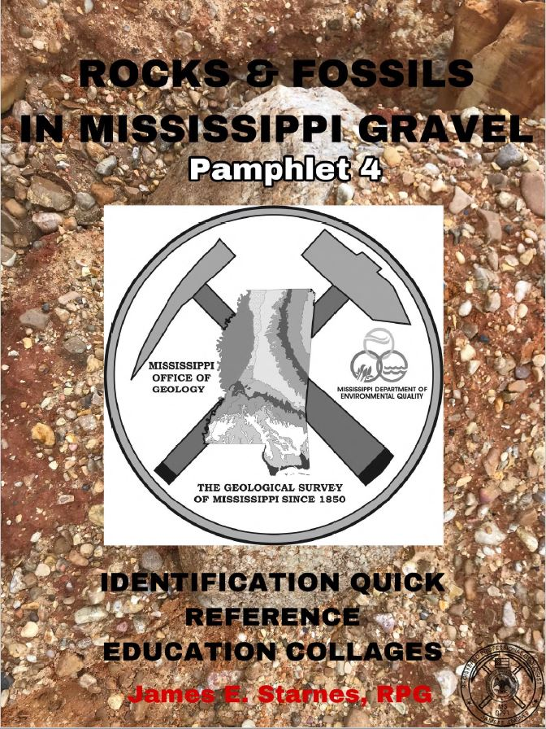

MISSISSIPPI OFFICE OF GEOLOGY ONLINE PUBLICATIONS
Currently available for download

Publication Type | Mississippi Department of Environmental Quality, Office of Geology
Title | Rocks & Fossils in Mississippi Gravel
Author | James E. Starnes, RPG
Year | 2019
Series | Pamphlet
Series Number | 4
Language | English
Publisher | Mississippi Department of Environmental Quality, Office of Geology
Publisher Location | Jackson, Mississippi
Description | 30 Pages

Abstract:
None.

