WEB ADDRESS: cdx.epa.gov or netdmr.epa.gov
1.At welcome page click on
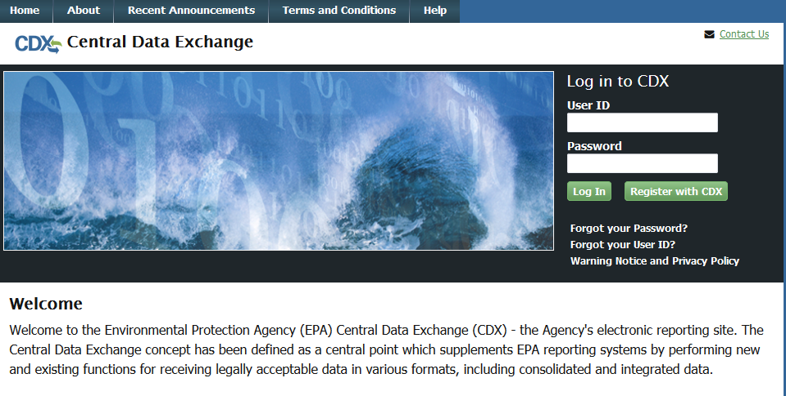
Next: Agree to Terms and Conditions
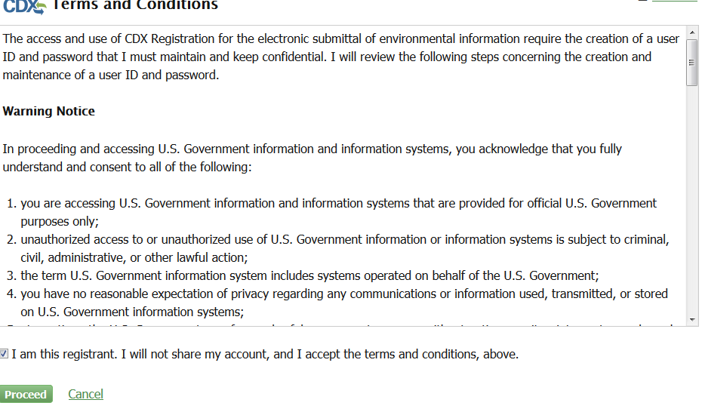

2.Choose Program Service Category from list:
You can type NetDMR to search
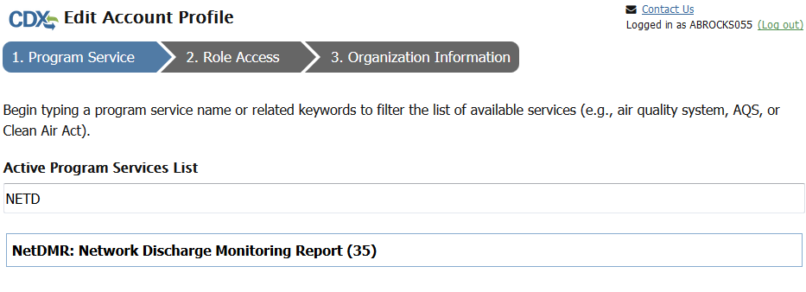
3. Choose Active Program Service from list:
Your Program Services is: NETDMR: MISSISSIPPI DEQ

4. Select Role: if Certifying the DMR, choose Permittee (Signature); if not signing DMR, choose Permittee (No Signature) or Data Provider. ‘INTERNAL USER’ ROLE IS ONLY FOR MDEQ OR EPA.
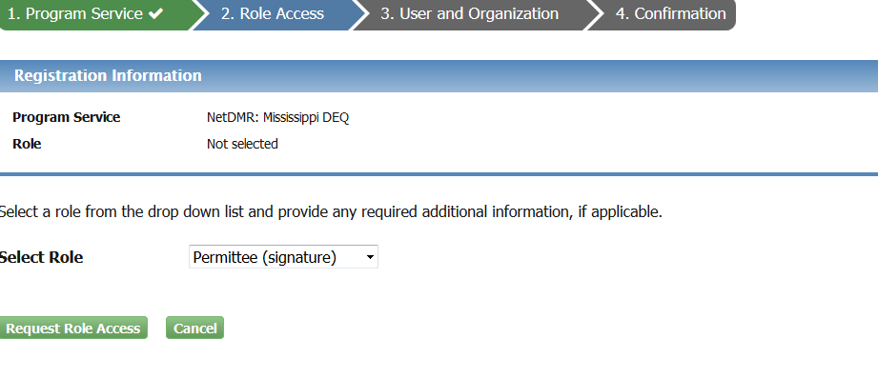
5.After choosing role, click ‘Request Role Access’
6. Complete User information and Organization (if your organization is not listed, please click ‘request to add organization’.
Password must be 8 characters long: 1 upper case with numbers.

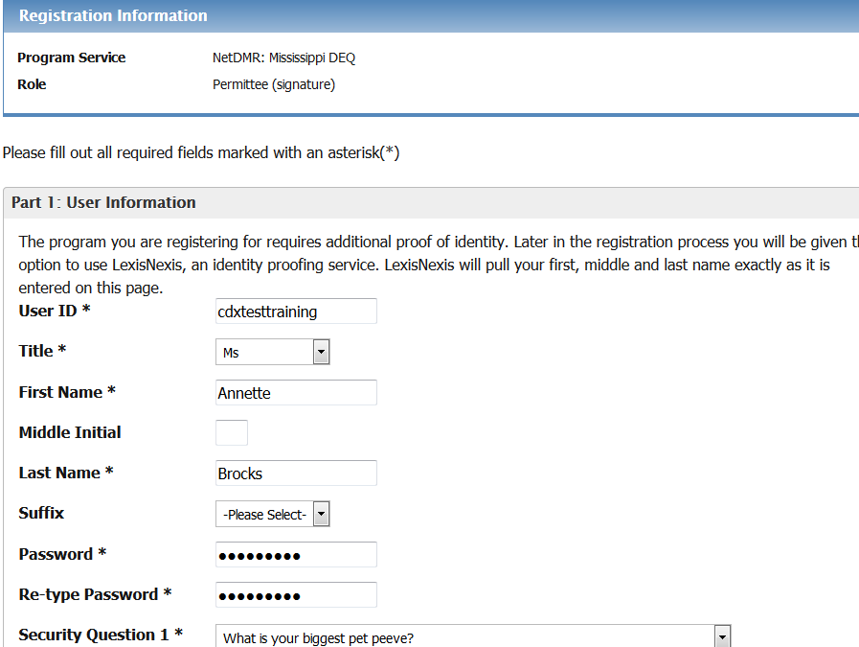
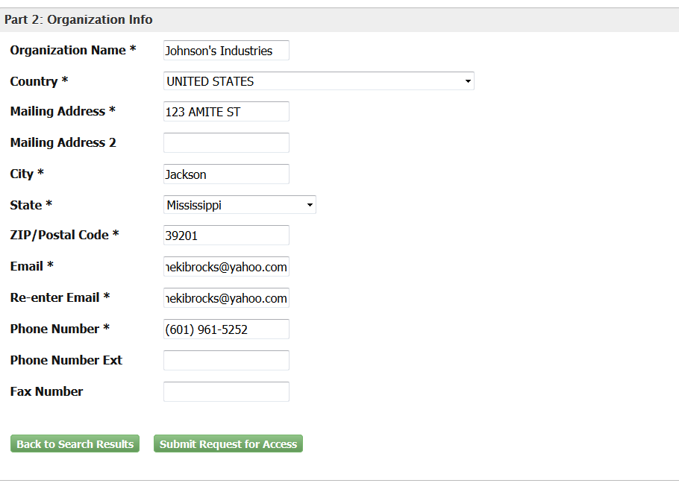
7. If you add your facility, you will be asked to close and You will receive an email link to complete the process.
8. Click on email; enter User Name and password you just established. Next enter Job Title.
9. This will take you to the Identity Verification:
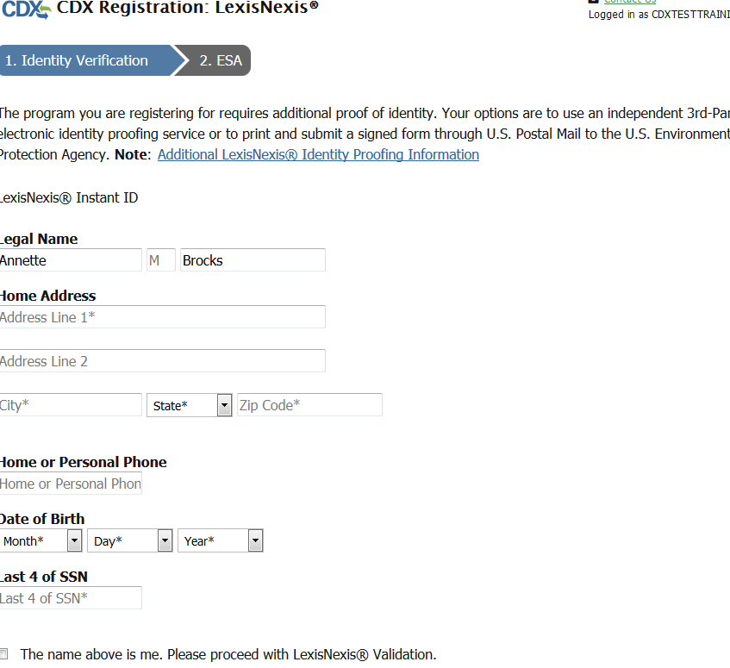
THIS WILL BE PERSONAL INFO ABOUT YOU: OR AT THIS POINT YOU CAN DO CHOOSE ‘PAPER VERIFICATION’.

10. Complete Signature Questions: These will be used when you Sign and Submit your DMRs.

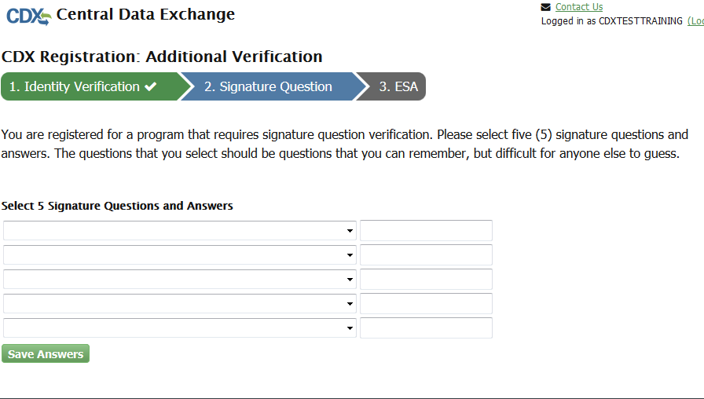
11. Read and Sign the Electronic Signature Agreement (ESA).
(YOU MUST BRING THE SCROLL BAR ALL THE WAY DOWN FOR THE SYSTEM TO KNOW YOU HAVE READ THE ESA) SEE YELLOW HIGHLIGHT
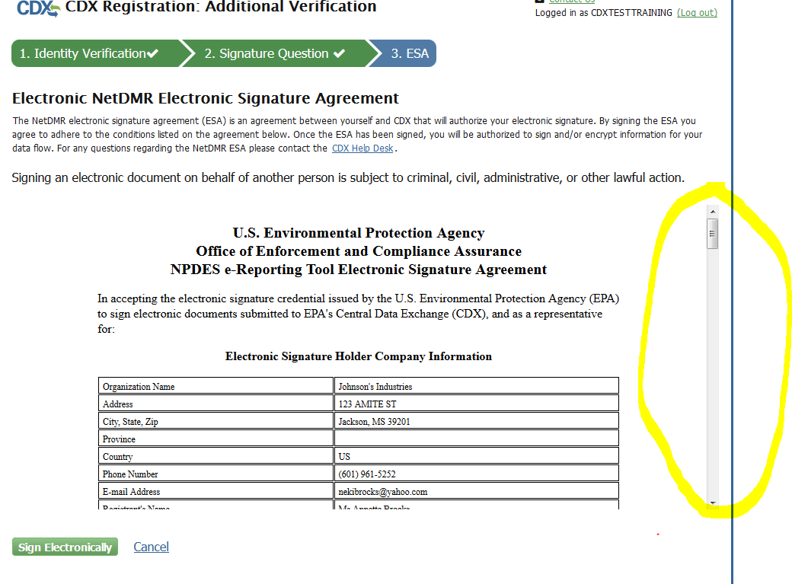
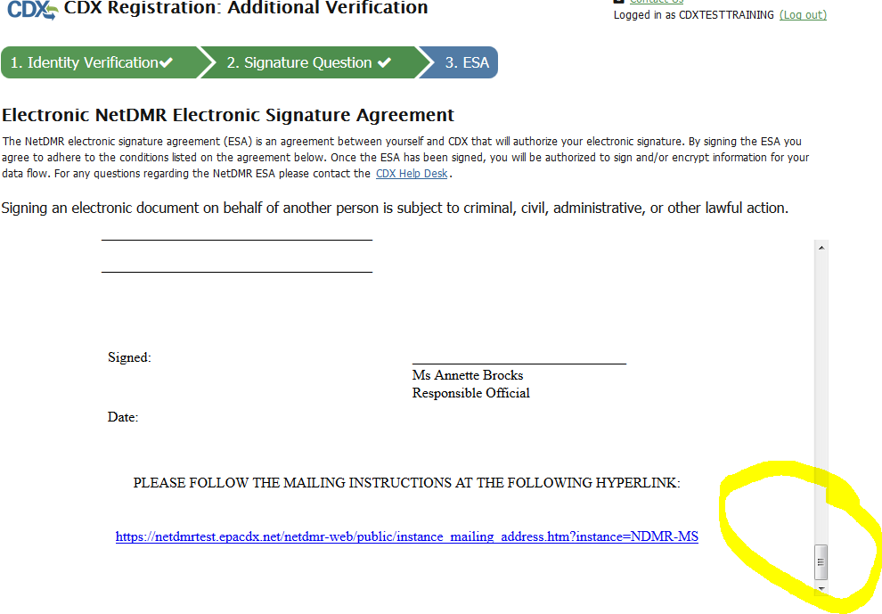
12. Click ‘Sign Electronically’
Agree to Sign Electronically.
Complete Authentication and Verification process

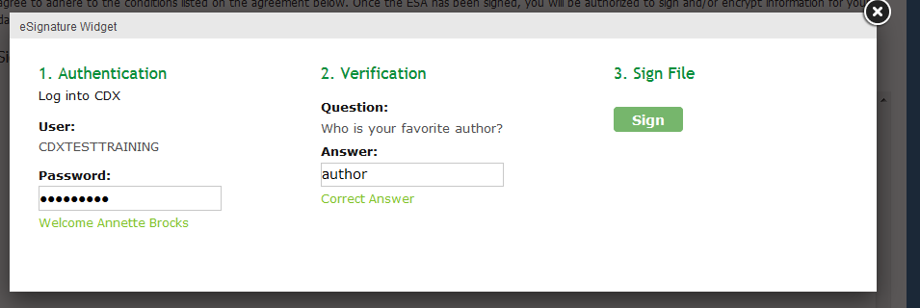

ONCE ACCOUNT IS CREATED, PLEASE FOLLOW THE STEPS BELOW:
After the account is created it will bring you to the log in page.
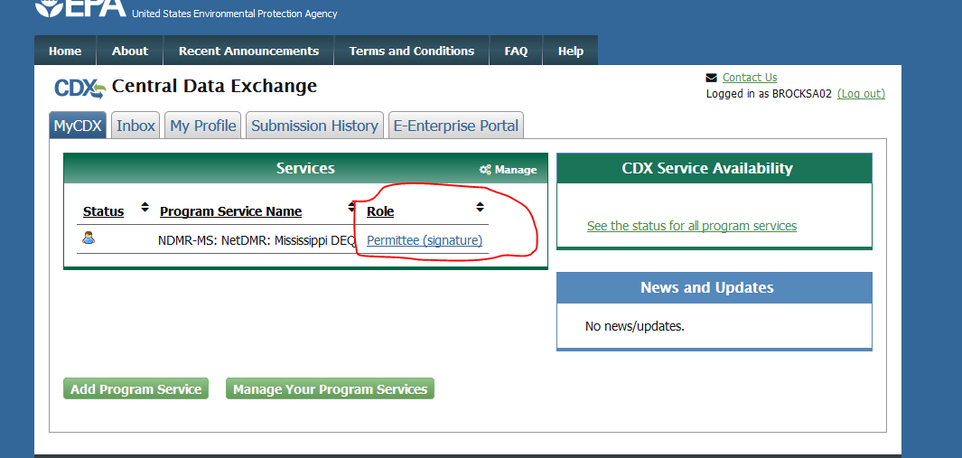

Log in and click on Permittee Signature under Role:
Continue to NetDMR
Click on Request Access
Enter permit id, click update
Add role Signature
Click Add request (repeat underlined section if you have more than one facility and want it all on one form)
Submit
Relationship to facility: click facility
I am authorized to enter data (FIRST RADIO BUTTON ONLY) if you are authorized to sign.*
*If you are being authorized to sign, please click second radio button and enter name, title, etc. Do not sign electronically, choose Sign Via Paper and print and email or fax to us.
Submit
CHOOSE sign electronically
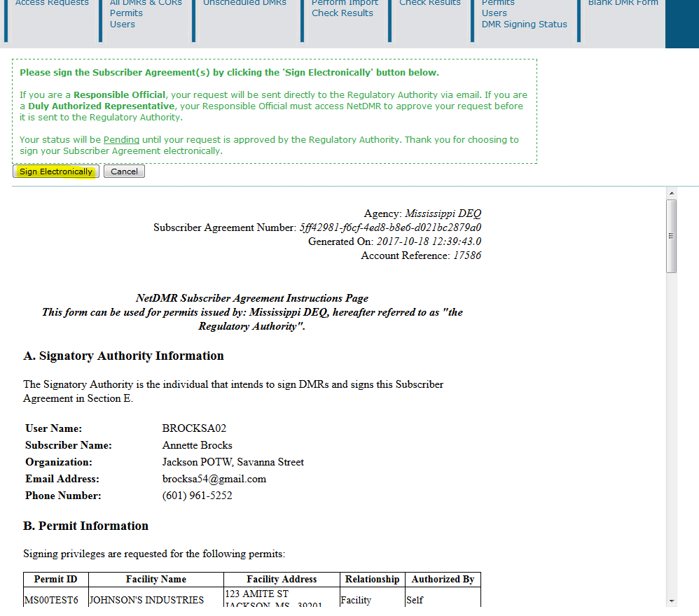
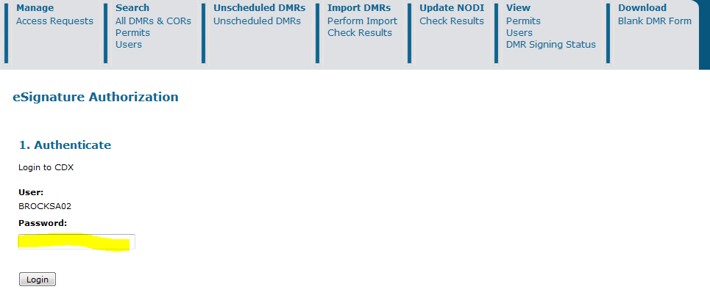
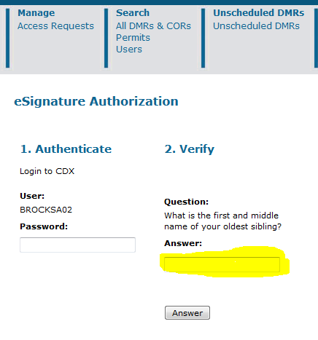
VERIFY: ANSWER SECURITY QUESTION AND THEN SIGN CLICK SIGN

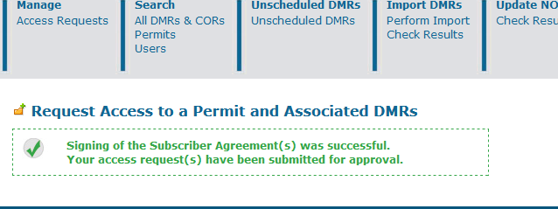
If you have questions, please feel free to call 601.961.5252.

