Publication Citation
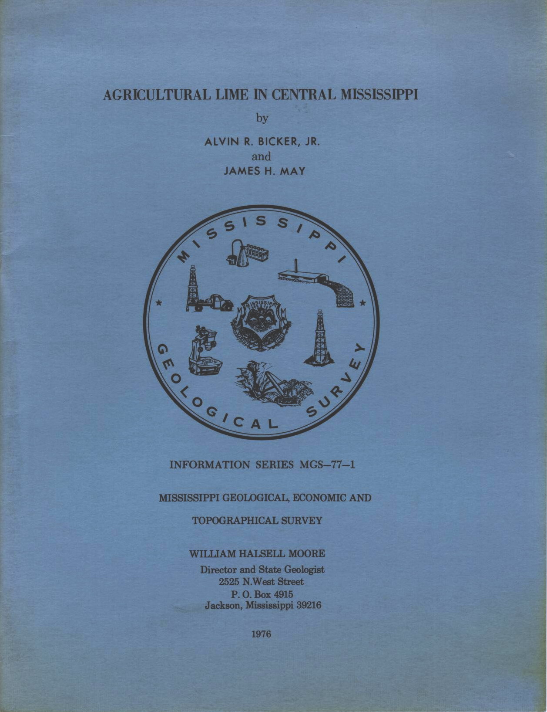

MISSISSIPPI OFFICE OF GEOLOGY ONLINE PUBLICATIONS
Currently available for download

Publication Type | Mississippi Geological, Economic And Topographical Survey
Title | AGRICULTURAL LIME IN CENTRAL MISSISSIPPI
Author | Alvin R. Bicker, Jr. And James H. May
Year | 1976
Series | Information Series
Series Number | MGS-77-1
Language | English
Publisher | Mississippi Geological, Economic And Topographical Survey
Publisher Location | Jackson, Mississippi
Description | 55 Pages, 19 Figures and Maps, 11 Tables

Abstract:
A report on the stratigraphy, areal extent, limestone thickness, overburden thickness, and quality of limestone along the Oligocene outcrop in Mississippi.

