Publication Citation
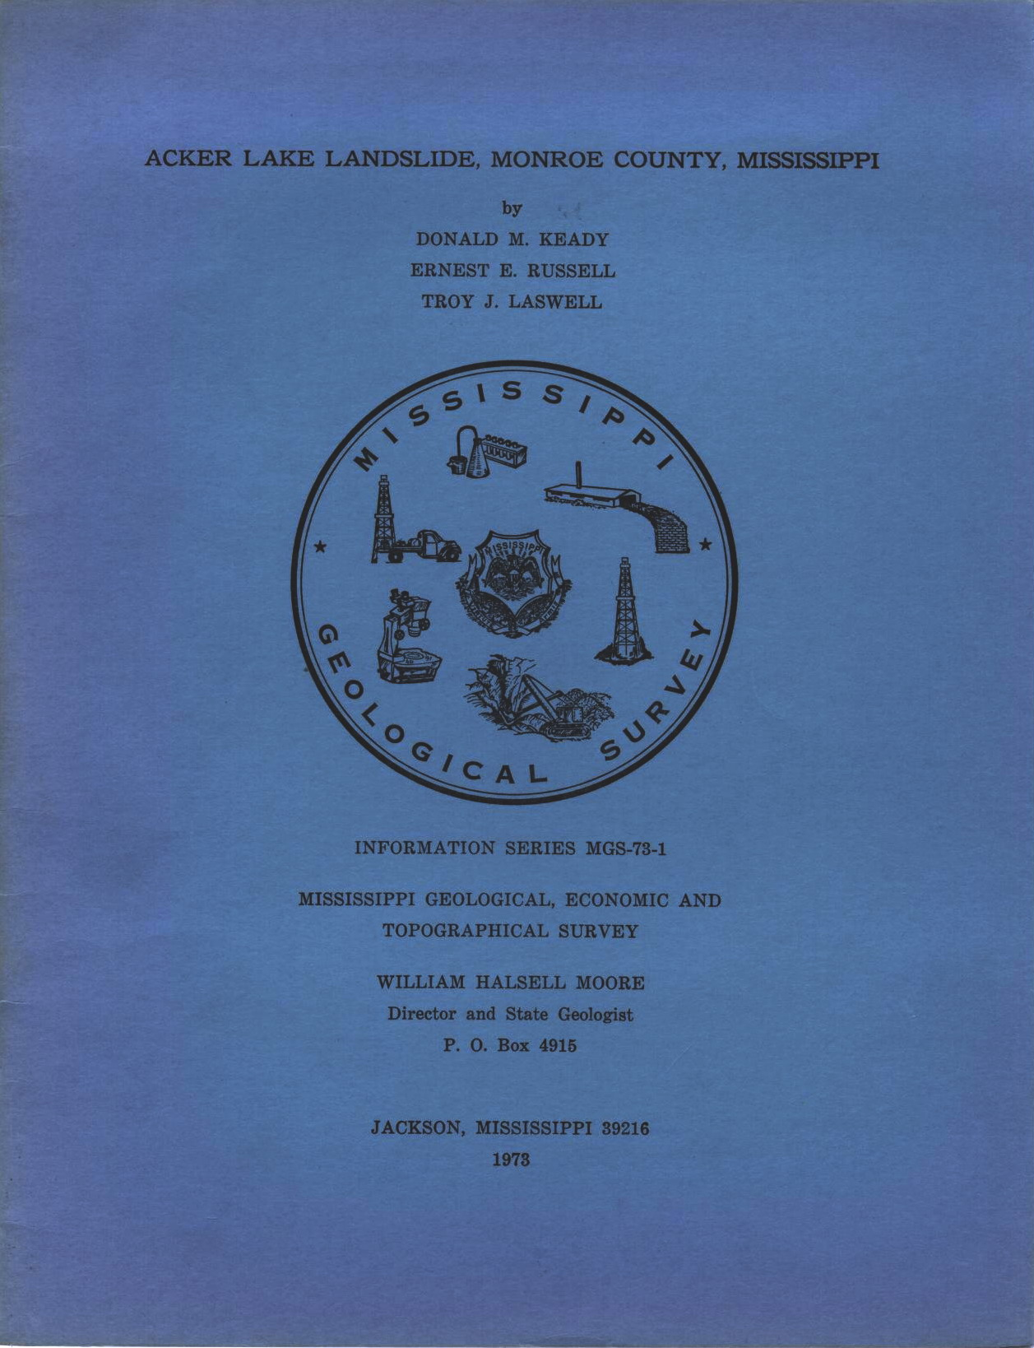

MISSISSIPPI OFFICE OF GEOLOGY ONLINE PUBLICATIONS
Currently available for download

Publication Type | Mississippi Geological, Economic And Topographical Survey
Title | ACKER LAKE LANDSLIDE, MONRORE COUNTY, MISSISSIPPI
Author | Donald M. Keady, Ernest E. Russell, Troy J. Laswell
Year | 1973
Series | Information Series
Series Number | MGS-73-1
Language | English
Publisher | Mississippi Geological, Economic And Topographical Survey
Publisher Location | Jackson, Mississippi
Description | 22 pages, 13 illustrations and maps

Abstract:
A report concerning a landslide of April 27, 1970, along the west wall of the Tombigbee River in Monroe County.

