Publication Citation
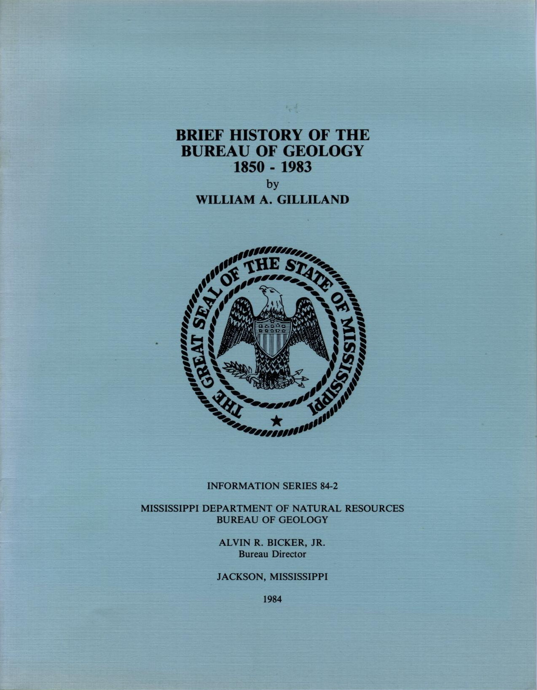

MISSISSIPPI OFFICE OF GEOLOGY ONLINE PUBLICATIONS
Currently available for download

Publication Type | Mississippi Department Of Natural Resources, Bureau Of Geology
Title | BRIEF HISTORY OF THE BUREAU OF GEOLOGY
Author | William A. Gilliland
Year | 1984
Series | Information Series
Series Number | 84-2
Language | English
Publisher | Mississippi Department Of Natural Resources, Bureau Of Geology
Publisher Location | Jackson, Mississippi
Description | 17 pages, 8 figures

Abstract:
The publication notes the origin of the Bureau and lists each State Geologist by tenure. Important activities during each period are recorded. Eight state geologic maps are reproduced in black and white.

