Publication Citation
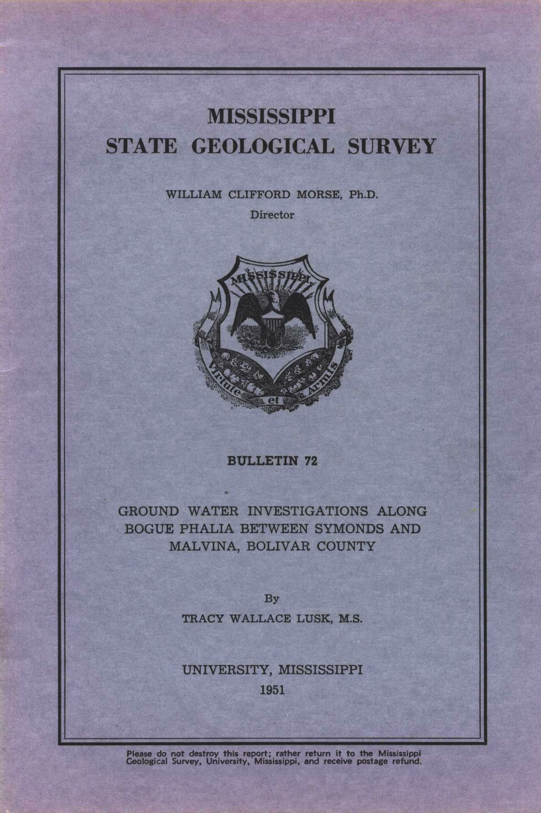

MISSISSIPPI OFFICE OF GEOLOGY ONLINE PUBLICATIONS
Currently available for download

Publication Type
Title | GROUND WATER INVESTIGAIONS ALONG BOGUE PHALIA BETWEEN SYMONDS AND MALVINA, BOLIVAR COUNTY
Author | Tracy Wallace Lusk, M.S.
Year | 1951
Series | Bulletin
Series Number | 72
Language | English
Publisher | Mississippi State Geological Survey
Publisher Location | University, Mississippi
Description | 19 Pages

Abstract:
Irrigation of rice fields led directly to the ground-water study of the area.

