Publication Citation
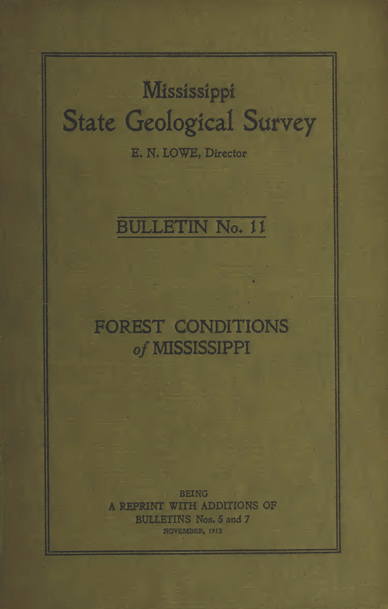

MISSISSIPPI OFFICE OF GEOLOGY ONLINE PUBLICATIONS
Currently available for download

Publication Type | Mississippi State Geological Survey
Title | FOREST CONDITIONS of MISSISSIPPI
Author | J. S. Holmes, J. H. Foster, C. E. Dunston
Year | November 1913
Series | Bulletin
Series Number | 11
Language | English
Publisher | Mississippi State Geological Survey
Publisher Location | Jackson, Mississippi
Description | 166 Pages

Abstract:
Being a reprint with additions of Bulletins nos. 5 and 7.

