Full Proposal Project Narrative Summary

Instructions: Save this document on your computer and complete the narrative in the format provided. The final narrative should not exceed fifty (50) pages; do not delete the text provided below. Once complete, upload this document into the on-line application as instructed. Note: the maximum file size allowed per upload is 15MB. When possible, larger graphics, including but not limited to, photos, organizational charts, work plan diagrams, and Gantt charts, should each be uploaded and appropriately labeled in the “Uploads” section as an appendix to the Proposal Narrative.
1) Project Goals and Objectives: What is/are the purpose(s) and objectives of the project? Describe how the project objectives remedy harm to natural resources impacted by the Deepwater Horizon event. What are the expected short-term net benefits to Gulf Coast natural resources and long-term measurable outcomes? How does the project measurably contribute to a priority natural resource outcome? If this project is a continuation or expansion of an existing project, describe the status and results/outcomes achieved to date. If the proposed work requests funding for an initial planning or design phase of a project, please describe any anticipated plans for project implementation and funding in the future.
Purpose
Mississippi’s coastal landscape, its natural resources, habitats and species that live here, are all critical pieces of the local and national communities. As a result of the Deepwater Horizon Oil Spill (DWH), Mississippi has an unprecedented opportunity to not only restore and foster our coastal landscape, but to advance these natural resources, habitats and species to levels of health and sustainability far beyond current levels. This restoration will be performed in accordance with the GEBF goals of restoring our coastal habitats and replenishing our living natural resources. An effort of this magnitude and importance is best accomplished through a comprehensive three year planning approach which coincides with GEBF funding and sustains far reaching legacy results. This proposal is designed in such a manner to:
- fully incorporate both individual and organizational stakeholders, in a transparent and inclusive development process resulting in science based strategies, program and/or project proposals, and results measurement with respect to NFWF GEBF funding;
- identify emerging themes and priorities of Gulf Coast restoration to achieve the greatest impacts and outcomes on Mississippi’s priority coastal habitats and living resources through the development of the Mississippi Comprehensive Ecosystem Restoration Tool (MCERT) - a tool to identify and examine ecological resources and threats at a landscape scale and ultimately improve restoration planning of the coastal landscape over time;
- identify and develop a prioritized list of projects which becomes a part of the overall Mississippi Comprehensive Restoration Plan (Plan). This list would initially shape project selection on an annual basis and solidify a direction for comprehensive coastal restoration upon plan completion, thus allowing for the majority of the GEBF funds in the latter years to be directed toward final plan objectives; and
- establish and achieve goals/objectives which transcend damage to Mississippi’s resources caused by the DWH Oil Spill and promote the long-term vitality and sustainability of all of Mississippi’s coastal habitat and living resources. The goals/objectives will encompass the GEBF Conservation Framework and the RESTORE Comprehensive Plan.
The importance of this proposal is designed to serve as an overarching framework for the identification of priority resource areas and, in concert with the objectives of NFWF, will provide for an iterative planning process. This iterative process allows for an optimization approach toward coastal restoration, providing the state with up-to-date information for annual program and project selection during the life of this proposed planning period and the life of GEBF funding, and inclusive of other RESTORE and NRDA funding streams.
Relevancy and Supporting Objectives
The unique cultural and economic fabric of the Mississippi Gulf Coast, along with its broad watersheds and rivers, provide a wide range of natural resource services including fisheries, food production, nutrient assimilation, energy production and recreational opportunities. The long-term viability of every one of these important community pillars is the health and productivity of the natural resources on which they rely. Mississippi’s coastal ecosystems and habitats and the rich array of species to which they provide a home create a coastline unlike any other coast. Some of these coastal ecosystems and habitats are depicted in Figure 1 below. These ecosystems and habitats are integral to not only the local Mississippi economy but to economies of the nation and the world.
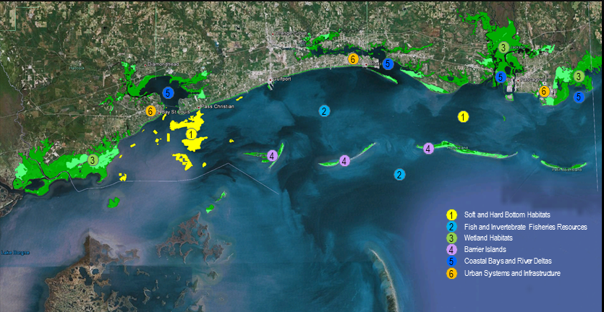
Figure 1 - Mississippi Coastal Ecosystems and Habitats
Restoration and conservation of coastal habitats, along with the replenishment and protection of living resources, can be better executed through a comprehensive approach to planning, design, and development. Listed below are the supporting objectives of this plan that will serve as the pathway to formulate these projects and programs and identify priority areas for restoration that have been affected by the DWH Oil Spill. Projects are considered as singular in nature and programs deal with the broader landscape, potential groups or suites of projects and more programmatic activities.
- Maximize program benefits by eliminating duplication with other restoration programs;
- Produce meaningful and measurable outcomes;
- Engage the expertise and support of key individual and organizational stakeholders to leverage results and commitment;
- Coordinate restoration activities for maximum environmental benefit;
- Produce science based activities and results;
- Exhibit cost effectiveness through the identification of possible leveraging opportunities with other funding sources or organizations; and
- Create synergy with priorities of other entities actively involved in restoration in the wake of the DWH; and address habitat and species by type impacted by the oil spill.
This proposal comes at a unique time in the history of the Gulf of Mexico. Stakeholders across the region bear the permanent scars of two catastrophic events of epic proportion in a five year period– Hurricane Katrina in 2005 and the Deepwater Oil Spill in 2010. The cumulative effect of these events was multifold, first yielding an unprecedented level of public skepticism concerning restoration activities in general as well as a strained relationship between the public and governmental entities charged with administering programs and projects to restore the Gulf region. Secondly, the two events combined to spawn an unprecedented level of study, report, and recommendation relating to the Gulf. Resultantly, the Gulf region is replete with plans, initiatives, programs, and studies, all purporting to speak on behalf of Gulf stakeholders.
Any state undertaking a comprehensive planning effort of this nature faces unique challenges in synthesis, alignment of effort among stakeholders and informed decision making which encompasses all relevant viewpoints. Moreover, the wide range of highly energized stakeholder organizations and individuals will demand real involvement in every aspect of the process before embracing any program or project it might yield. Stakeholder engagement cannot be “business as usual” in the current Gulf environment. This proposal recognizes that challenge and seeks to create a model for engaging stakeholders which can become the gold standard for efforts of this nature and scope in the future.
After the DWH Oil Spill, the Gulf of Mexico coastal area has been the center of attention for a number of worthy planning efforts. As valuable as these plans may be, most were not done in context with other plans and many are dated to some degree. This proposal offers the first opportunity for Mississippi to update, streamline, and think across all existing plans and all potential funding platforms to promote a truly comprehensive approach to restoration planning. Large scale existing planning efforts which would be important to incorporate and vet include, but are not limited to, the Gulf of Mexico Regional Ecosystem Strategy, the RESTORE Act, the Mississippi Coastal Improvement Program (MsCIP), Coastal Impact Assistance Program (CIAP), GoCoast 2020, State Wildlife Action Plan (SWAP), Natural Heritage Program (NHP), among others.
In addition to attention to past efforts, Mississippi will carefully review existing and/or emergent planning documents to correlate important data and findings as well as information available through the DWH Natural Resource Damage Assessment (NRDA) to take a new and current snapshot of the health status of Mississippi’s coastal resources. Existing and potential monitoring activities planned by a number of entities will be strengthened and supplemented by monitoring which will occur on every project funded by GEBF. Critical information which will be mined as a result of this planning proposal will be combined with geospatial techniques to develop criteria which yield important restoration priorities that are soundly related to ecosystem stressors and resulting threats to ecosystem services. These criteria will become an important touchstone in the identification and selection of priority projects.
An important aspect of this proposal is the creation of a revolutionary new model for stakeholder engagement activities across the wide spectrum of interested stakeholders. Unlike traditional engagement efforts, which typically follow a limited approach by which comment is received from stakeholders only after substantial work has progressed, the model anticipated by this proposal establishes a much more robust and early term use of stakeholder expertise, particularly that which is housed in environmental non-governmental organizations as well as in other organizations and scientific sectors. A primary distinguishing factor of this approach is the discrete use of stakeholder input to inform decision making, and to provide critical consultation around the resources and resource types appropriate for GEBF funding.
This proposal is also designed to construct a greatly improved, two-way public engagement process which further energizes and coordinates a strong and divergent body of passionate general public stakeholders across the entire coastal landscape. Mississippi prides itself on having adopted immediately following the oil spill, a transparent public engagement platform which urges the involvement of a host of stakeholders at points of time far in advance of project selection. This lateral engagement includes federal and state agencies, non-governmental organizations, communities and community based organizations, elected and appointed officials, the science community and the corporate community. This process is designed to extract stakeholder assets to build a sound decision making process throughout every facet of the plan.
The state will utilize the wealth of talent available through non-governmental organizations that have extensive experience with Mississippi’s coastal resources and are respected long term partners to NFWF. These stakeholders have an abundance of knowledge about restoration priorities, best science, implementation and monitoring practices; an approach which incorporates reliance on this knowledge is a cornerstone of this proposal. Finally, the state will seek and integrate the knowledge and expertise of other governmental entities, both state and federal, to lift and leverage the results of the stakeholder effort. There are a host of stakeholders across the Gulf Coast whose voices are all lifted toward restoration and long term enhancement. This stakeholder approach seeks to turn those voices into a chorus.
Short-term benefits of this approach include a streamlined, unified restoration effort across the Gulf Coast which has the support of a wide stakeholder base. By aligning supportable restoration strategies across all funding sources, Mississippi seeks to eliminate duplicity and to begin to build future restoration investment opportunities. A second short-term benefit will be collaborative and cooperative planning efforts by all interested parties across the Gulf Coast. By bringing many different audiences across the Gulf Coast together in assessing and planning, restoration priorities are teed up for long-term, sustainable growth and success. The long-term measurable outcomes include the development of MCERT and a prioritized list of projects developed for future consideration. Additional long term results include an ability for the varied coastal stakeholders to fully understand and embrace the importance of a long term approach to resource enhancement and protection, an ability for funders and policy makers to make decisions which are meaningful, coordinated, and sustainable, and a format which supports generational planning rather than incremental planning.
2) Scope of Work:
- Provide a comprehensive narrative statement that describes the methodology that will be used to complete the Scope of Work. This methodology should detail and thoroughly describe the primary tasks, the activities and deliverables associated with each task, and how each task will address the objectives and target outcomes described above. If applicable, describe any planning, design/engineering, and permitting that will be required prior to beginning any project construction and how the project team will complete those necessary steps and obtain all relevant permits.
Narrative
When evaluating the Scope of Work to be performed, five major phases of work become the predominate drivers within the science and public engagement arenas.
- Assessment
- Evaluation and Planning
- Development
- Adaptive Management
- Program Management

