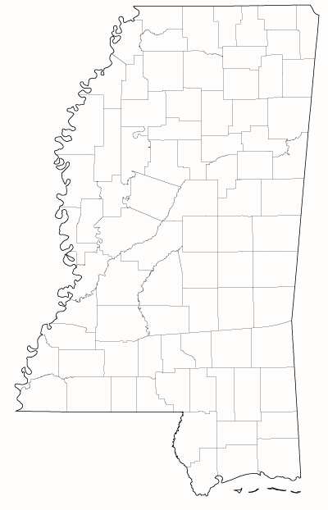

**Pascagoula, MS**

**Jackson County**

**AIRS# 280590006**

**Gulfport, MS**

**Harrison County**

**AIRS# 280470008**

**Stennis Space Center**

**Hancock County**

**AIRS# 280458201**

**Enterprise, MS**

**Clarke County**

**AIRS# 280235501**

**Jackson, MS**

**Hinds County**

**AIRS# 280490010**

**Columbus, MS**

**Lowndes County**

**AIRS# 280870002**

**AIRS# 280870003**

**Grenada, MS**

**Grenada County**

**AIRS# 280430001**

**Tupelo, MS**

**Lee County  
AIRS# 280810005**

**Air Toxics Monitoring Sites in Mississippi**