HOW TO USE THIS EMERGENCY ACTION
PLAN (EAP) TEMPLATE:

- Complete a dam breach analysis using an appropriate hydraulics model (i.e. HEC-RAS, FLO 2-D, GeoDamBreach) Note: For instructions on doing a breach analysis, please see Chapter 20 H & H of the plan review checklists available on the MDEQ Dam Safety webpage.

- Develop an inundation map in accordance with the standards shown on the (Insert Inundation Map) page of this template.

- Insert the information relevant to this dam in the areas where Red text is shown. Edit any additional red text and then change all Red text back to Black.

- Submit a draft EAP to MDEQ Dam Safety for review.

- After reviewing, MDEQ Dam Safety will sign the List of EAP Holders Page and return to you with any comments on the EAP.

- Once any corrections to the EAP are made based on our comments, distribute the EAP to the remaining EAP holders and then submit a completed List of EAP Holders page to MDEQ Dam Safety along with a digital and hard copy of the Final EAP.

- MDEQ Dam Safety will issue final approval of the EAP.

EMERGENCY ACTION PLAN

FOR

(INSERT DAM NAME)

STATE ID MS0XXXX

(INSERT COUNTY NAME), MISSISSIPPI

(INSERT DATE)

Access to the Dam during Emergencies:
Primary access to the site is by (name of road that isn’t threatened by dam failure). The dam may also be reached by (insert name of route). With the exception of (name of route), none of these routes is susceptible to inundation in the event of dam failure.

Prepared by:
(Name, Company Name, or HOA)
(Address)
(Phone Number)

TABLE OF CONTENTS

INUNDATION MAP 3

LIST OF ROADS/RESIDENCES IMPACTED 4

- EMERGENCY DETECTION, EVALUATION & 5
CLASSIFICATION
- LOCATION AND DESCRIPTION OF DAM 12
AND OUTLET WORKS

- DAM BREACH ANALYSIS 12

- GENERAL RESPONSIBILITIES UNDER THE PLAN 13

APPENDIX
APPROVALS AND ACCEPTANCE OF THE EAP 14

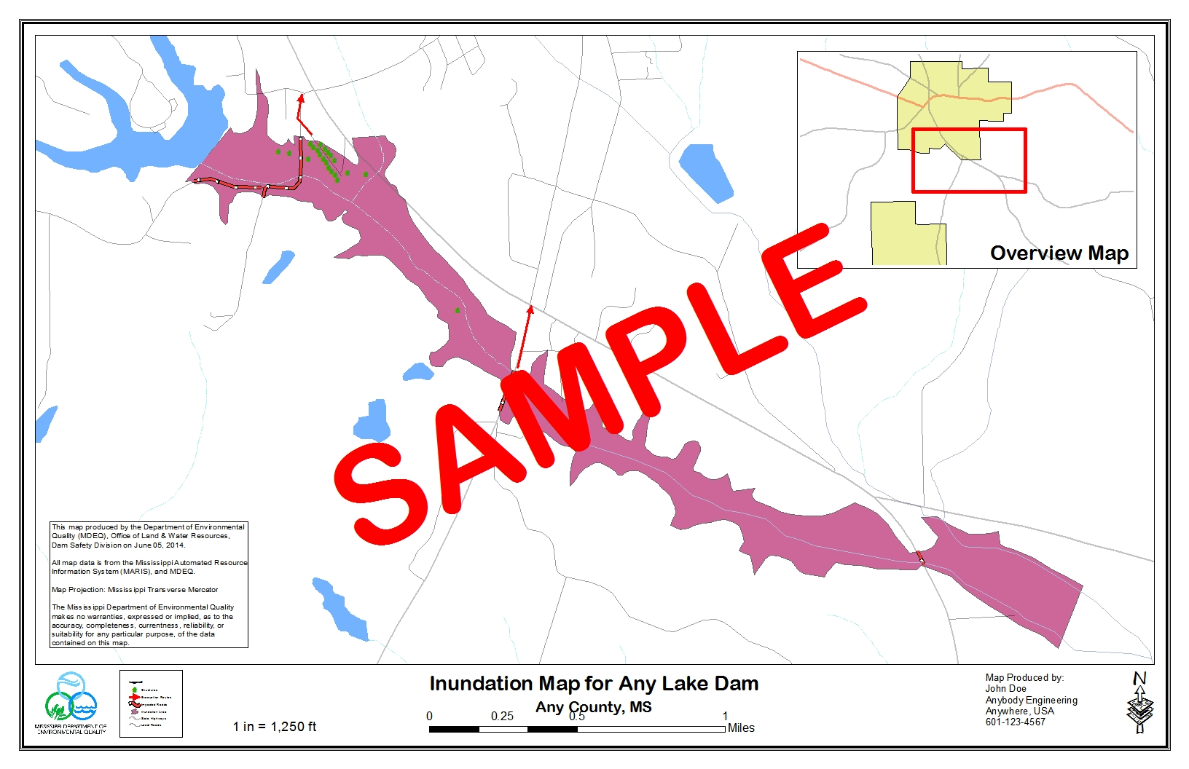

Standards for the Inundation Map:
- The inundation area should be clearly identified with all homes, structures, roads, etc. that will be impacted clearly labeled.
- Evacuation routes should be labeled with directional arrows.
- The map should include a North Arrow and the name and contact information for the individual/company that developed the map.

NEWS RELEASE:
The owners of ________ Dam have announced that it is in imminent danger of failure. The dam is located _____ (north, south, east, west) of _______ (nearest major landmark), in ______ Subdivision (or area), off _______ Road between ______ Road and _____ Road. Streets (roads) within the area which will be affected are: _______ Road, ______ Drive, ______ Drive, ______ Drive, ______ Drive, _______ Drive (North and South), and _____ Highway. Residents along these streets should evacuate to high ground immediately.

ROADS TO BE CLOSED:
(Insert road names and approx. locations where they should be closed)

RESIDENCES TO BE EVACUATED:

(Name)
(Address)
(Phone Number)

(Name)
(Address)
(Phone Number)

- EMERGENCY DETECTION, EVALUATION AND CLASSIFICATION

Upon discovery of a problem at a dam, the dam owner and/or on-site personnel should decide which category the emergency situation falls under. If there is any uncertainty about the classification of the emergency, the situation should be classified as a Warning, unless there is an uncontrolled release of water which would constitute an Emergency. The four dam emergency classification types are outlined below:

- Emergency: Uncontrolled Release of Water

- Warning: Failure Could Happen at Any Time

- Watch: Potential for Failure Exists

- Advisory: Conditions that could lead to a failure situation have occurred

These conditions are further defined in the following sections.

Emergency – Uncontrolled Release of Water

The dam is failing and there is an uncontrolled release of water.

On-Site Personnel Plan of Action

Move a safe distance away from the dam and call the following people and explain to them that the dam is failing and downstream residents should be evacuated immediately:
  - 911
  - County Emergency Manager (xxx-xxx-xxxx) The county emergency manager should notify the National Weather Service (xxx-xxx-xxxx) to issue a Flash Flood Warning. In the case of dams with large populations at risk, the NWS may issue a Flash Flood Emergency.
  - Downstream Residents to be evacuated as shown on page 4 of this plan.

Warning – Failure Could Happen at Any Time

Common warning signs are:
  - whirlpool developing in the lake near the dam
  - a major slide of material in either face of the dam that reaches the top of the slope or extends into the crest of the dam
  - overtopping
  - (any other conditions that may constitute imminent failure or downstream flooding for this particular dam, like activation of emergency spillway)
On-Site Personnel Plan of Action

- Make the necessary phone calls as shown in the flowchart on Page 6. During the calls do the following:
  - Explain that the dam could fail at any time.
  - State you are classifying this as an imminent failure. In this case, a Flash Flood Warning should be issued by the National Weather Service. If needed, relay the News Release on Page 4 of this plan.
  - Refer them to the inundation map and downstream contact list for this EAP to determine which area should be evacuated.
  - Give them the name and number of someone who can be called back for any follow-up questions.

- If possible, notify anyone in the nearby vicinity of the dam to evacuate and move back a safe distance from the dam and inundation area.
MDEQ Dam Safety
24 Hr. 1-855-264-6665
First Responders:
(?) Police Dept.
xxx-xxx-xxxx
(?) Fire Dept.
xxx-xxx-xxxx

Emergency medical services:
(Insert Name and Phone Number)
MEMA
1-800-222-6362
Owner:
(Insert Owner’s Name)
xxx-xxx-xxxx

Consulting Engineer:
(Insert Engineer’s Name)
xxx-xxx-xxxx
County and State Highway Dept.
Railroads
Primary Utilities
National Weather Service
(Look up District and Phone # from the map
on the last page and
insert here)
(?) County EMA
24 Hr. xxx-xxx-xxxx
Days xxx-xxx-xxxx

Call 911
Warning

Watch - Potential for Failure Exists

Common warning signs are:

- seepage found that increases in flow or new seepage points develop while situation is being monitored
- sand boils (water exiting the ground surface with enough velocity to cause the soil/water mixture to appear to be boiling) that develop downstream of the dam, note that a boil that steadily increases in diameter or appears to boiling more vigorously because of rapidly increasing flow would move the situation from a Watch to an Emergency
- piping (a concentrated flow of water with sufficient velocity to transport soil particles – generally indicated by an identifiable hole, or “pipe”, surrounded by a cone of soil) note that an increase in the diameter of the “pipe” or rapidly increasing flow would move the situation from a Watch to an Emergency
- slides of material that only affect the face of the dam and have not affected or progressed into or under the crest of the dam, or gullies forming in the face of the dam sinkholes found in the dam
- Water levels nearing the top of the dam and steadily increasing. This includes activation of the emergency spillway if downstream residents could be flooded.
- (any other conditions that may constitute a potential failure situation)
NOTE: Discovery of a sand boil or evidence of piping in the dam face or in the vicinity of the toe of the dam should cause the observer to immediately expand the area of surveillance to include all areas, particularly areas that are at a lower elevation than the observed problem, within 200 to 250 feet of the downstream toe of the dam. Also, if an earthquake occurs and registers more than 6.0 in the general area of the state where your dam is located then the dam should be inspected as soon as possible and the lake level drawn down 1/3 to 1/2 of the greatest depth of the lake until an engineer can inspect the dam for damage.

On-Site Personnel Plan of Action

- Make the necessary phone calls as shown in the flowchart on Page 9. During the calls do the following:
  - Explain the problems with the dam.
  - State you are classifying this as a potential failure. In this case, a Flash Flood Watch should be issued by the National Weather Service. If needed, relay the News Release on Page 4 of this plan.
  - Refer them to the inundation map and downstream contact list for this EAP to determine which area should be notified of the potential need for evacuation. In some cases, the County EMA may wish to issue a voluntary evacuation notice.
  - Give them the name and number of someone who can be called back for any follow-up questions.

- Work with the Consulting Engineer, Contractor, and MDEQ Dam Safety to try and prevent failure of the dam.

Note: At any point if conditions worsen at the dam, this emergency should immediately be re-classified as a Warning. On-Site personnel should dial 911 and notify the National Weather Service to issue a Flash Flood Warning.

Watch

National Weather Service
(Look up District and Phone # from the map
on the last page and
insert here)
MEMA
1-800-222-6362
(?) County EMA
24 Hr. xxx-xxx-xxxx
Days xxx-xxx-xxxx
Consulting Engineer:
(Insert Engineer’s Name)
xxx-xxx-xxxx

Contractor assistance for equipment and materials for repairs:

Primary:
(Insert Contractor’s Name)
xxx- xxx-xxxx
Cell phone xxx- xxx-xxxx

Backup:
(Insert Contractor’s Name)
xxx- xxx-xxxx
Cell phone xxx-xxx-xxxx
MDEQ Dam Safety
24 Hr. 1-855-264-6665
Weekdays 601-961-5171
Advisory – Conditions that could Lead to a Failure Have Occurred

Some conditions that could lead to a failure:

- Seepage that has recently developed.
- Excessive rainfall that may exceed the capacity of the spillways. (Insert Dam Name) should be monitored when rainfall amounts exceed (Insert Rainfall Amounts and Time Frame).
On-Site Personnel Plan of Action

- Make the necessary phone calls as shown in the flowchart on Page 11. During the calls do the following:
- Explain the problems with the dam. If this advisory is due to excessive rainfall, you should also contact the National Weather Service at xxx-xx-xxxx.
- Give them the name and number of someone who can be called back for any follow-up questions.

- Work with the consulting engineer and MDEQ Dam Safety to determine a path forward.

Note: If water levels are rapidly rising due to a storm event that is expected to exceed the capacity of the spillways, this emergency should immediately be re-classified as a Warning and the steps shown under the Warning section of this EAP should be implemented. If seepage is increasing in flow or new seepage points are developing, this emergency should be re-classified as a Watch and the steps shown under the Watch section of this EAP should be implemented.
National Weather Service
(Look up District and Phone # from the map
on the last page and
insert here)
(?) County EMA
24 Hr. xxx-xxx-xxxx
Days xxx-xxx-xxxx
MDEQ Dam Safety
24 Hr. 1-855-264-6665
Weekdays 601-961-5171
Consulting Engineer:
(Insert Engineer’s Name)
xxx-xxx-xxxx

Advisory

- LOCATION AND DESCRIPTION OF DAM AND
OUTLET WORKS

(Insert Dam Name) is located in the city of (Insert City Name), (Insert County Name) County, Mississippi. The dam owner is (Insert Owner’s Name) (hereafter referred to as “the owner”). The primary function of the lake is (Select One: flood control, water supply, recreation, storm water retention, etc) for (Insert name of entity or persons served). The dam was constructed in (year). The dam and lake characteristics were determined by topographic and field surveys (or, determined by checking against the as-built plans). At its normal pool elevation of (Insert elevation) ft., (Insert Dam Name) impounds approximately (Insert storage volume) acre-feet with a surface area of about (Insert surface area) acres.

The principal spillway is located (describe where located in relation to dam, center, right abutment, left abutment, etc.). The principal spillway consists of a (describe spillway) and will carry a maximum flow of (Insert flow) cubic feet per second (cfs). The emergency spillway is located (describe location). The emergency spillway consists of (describe spillway) and will carry a maximum flow of (Insert flow) cfs. The lake drain is located at (describe).

Note: If available, insert an aerial photograph of dam with the approximate location of all outlet works/drains marked.

- DAM BREACH ANALYSIS

Note: Modify this section as needed. See Chapter 20 H&H of the Plan Review Checklists for guidance on breach analysis.

For the dam break analysis, the computer model (insert name of model) was used. This program simulates a breach, its resulting flood peak, and uses unsteady flow principles to route the flood through the downstream valley.

The top-of-dam elevation was used for the water-surface elevation at the beginning of the dam break (“wet-weather” case). The storm event used for the wet weather case was (state storm event – see dam safety regulations for guidance).

Normal pool elevation was used for “sunny day” failure (or state why “sunny day” failure is unlikely, ie. Dam is for flood control and normal pool is set so low as to not pose a hazard).

The results of the downstream flood routing were used to establish the limits and plot the inundated areas for emergency conditions associated with the dam break discharge. The map shown on Page 2 depicts the area which would be flooded should the hypothetical emergency occur. Shown below is a list of the inputs and boundary conditions used for the computer model:

- GENERAL RESPONSIBILITIES UNDER THE PLAN

- Dam Owner/ On-Site Personnel Responsibilities

Upon notification or discovery of the potential for an emergency situation, the dam owner and/or On-Site Personnel should take the appropriate action as outlined in the Emergency Detection, Evaluation, and Classification section of this plan.

- Responsibility for Evacuation

Warning and evacuation planning are the responsibilities of local authorities who have the statutory obligation. Dam owners should not assume, or usurp, the responsibility of government entities for evacuation of people. However, there may be situations in which routine notification and evacuation will not suffice, as in the case of a resident located just downstream of the dam. In this case, the dam owner should arrange to notify that person directly. This procedure should be coordinated with the appropriate public officials before an emergency situation develops.

- Responsibility for Duration, Security, Termination, and Follow-Up
The county EMA should perform on-site monitoring of the situation at the dam and keeping local authorities informed of developing conditions at the dam from the time he arrives on site until the emergency has been terminated. The state dam safety program, in consultation with the county EMA, is responsible for declaring that the emergency at the dam is terminated. Following that declaration, the county EMA is responsible for termination of the disaster response activities.

D. Exercising and Review of the EAP

A review of the adequacy of the EAP shall be conducted annually. Any comments from the evaluation will be used to update the EAP. The EAP should be updated promptly after each change in involved personnel or their telephone numbers, or after completion of a scheduled exercise. The EAP should be exercised annually.

APPENDIX:

APPROVALS AND ACCEPTANCE OF THE EAP
LIST OF EAP HOLDERS

DATE:

By my signature below, I certify that I have a copy of the EAP and I understand my role, or the role of my agency, in implementing the EAP for (Insert Dam Name),(MS0XXXX )if the need arises.

COPY # EAP HOLDER SIGNATURE

1. (name) – Dam Owner ________________

2. (name), (name) County EMA ________________

3. MDEQ, OLWR, Dam Safety Division ________________

4. (name) Police Department ________________

5. (name) Fire Department ________________

6. (name) Engineering & Surveying, LLC ________________

7. National Weather Service – (office) ________________

8. 911 Call Center ________________

SIGNATURES OF AGREEMENT

We, the undersigned, on the date indicated, have reviewed the requested support activity in the Emergency Action for (Insert Dam Name). Our support action will be executed in accordance with existing standard operating procedures and/or municipal or county emergency operation plans.

______________________________________________ ______________
(name), (name) County EMA Date

______________________________________________ ______________
(name) County 911Call Center Date

APPROVAL OF THE EAP

The Emergency Action Plan for (Insert Dam Name),(MS0XXXX ) is hereby approved.

______________________________________________ ______________
Dam Safety Division Date
Mississippi Department of Environmental Quality

