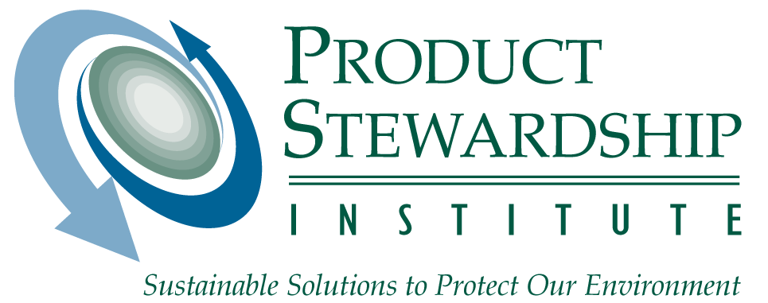

MANAGING NON-REFILLABLE GAS CYLINDERS:
RECOMMENDATIONS FOR MUNICIPAL AND COUNTY OFFICIALS

July 16, 2003

Deciding Whether To Implement A Municipal Or County Gas Cylinder Collection And Handling Program

In order to build support for a collection and handling program for non-refillable gas cylinders, it is important to understand the perceived risk posed by the cylinders and the likelihood of a dangerous incident, as well as the economic incentives and constraints influencing program development. Questions that decision-makers should ask themselves include:

- SAFETY: Have there been incidents with pressurized gas cylinders at the landfill, waste-to-energy plant, scrap metal processing facility, in trash compacting trucks, or elsewhere? Is garbage handled in a way that may increase the likelihood of explosions?
Certain methods of treating garbage – such as shredding before incineration or multiple compaction processes – create more opportunities for gas cylinders to ignite or explode. Even anecdotal evidence of pressurized gas cylinder problems can create an impetus for cylinder management programs. Since source explosions can be hard to trace, it may be prudent to manage all types of pressurized gas cylinders with the same degree of caution.

- ECONOMICS: Is cylinder management feasible economically?
There are ways to reduce the cost of managing cylinders. For example, by reducing the risk, or perceived risk, for scrap metal recyclers to accept cylinders for recycling, increased markets could lower collection costs. However, even so, cost can be a significant obstacle to municipal investment in a cylinder management program.

- VOLUME: Are a significant number of cylinders generated in your jurisdiction?
If the number of cylinders is significant (or could be if combined with those from neighboring areas), a cylinder management program presents an opportunity to increase the recovery of scrap steel in your community.

- CONTEXT: Do neighboring areas handle non-refillable gas cylinders?
Cylinder management standards in neighboring municipalities or counties can impact your operation. If a program exists nearby, you may be able to take advantage of existing facilities and contracts. If none exists, you may want to determine if there might be difficulties arising from different local policies. For example, some government agencies allow the disposal of gas cylinders in county landfills or incinerators. Cylinders collected from one county could find their way into another county’s landfill. If no program exists in neighboring counties, an opportunity may exist for the establishment of a regional gas cylinder recycling program.

If the answer to all, or most, of the above questions is yes, there is a good likelihood that a non-refillable cylinder collection and handling program could be supported in your area.

Creating a Cylinder Collection and Handling Program

After deciding to create a program, you will need to investigate your own waste management systems and determine how cylinders will be identified in the waste stream and what infrastructure is needed to support collection. Additionally, you should determine which scrap metal recyclers in your region will accept cylinders, and under which conditions, before you start collecting them. The following options for handling cylinders are listed in order of preference:

(1) Hire Expertise

The best way to handle non-refillable gas cylinders may be to establish a contractual agreement with a business that has the capability to professionally collect and safely process cylinders. Cylinders need to be vacated of any remaining gas, and then are often punched or cut to indicate that they are empty. In some cases, however, contractors that own equipment that can safely prepare cylinders have little incentive to accept them. Municipalities and counties can maneuver around these obstacles by taking the following measures:

- Include cylinder management services in solid waste collection contracts: Contract language in typical solid waste management contracts could specify that trash haulers collect cylinders and either process them safely with their own equipment or transport them to an approved metal recycling facility. Consider adding cylinder management services onto contracts to manage products with higher market value, such as white goods. By combining a high value material with one with low value, you are more likely to receive contractor bids that will result in the acceptance and processing of non-refillable cylinders. Recycling contracts should also specify that the cylinders not be disposed.
- Create partnerships with tank refurbishing operations: Tank refurbishers are interested in collecting 20-pound propane tanks since their business is predicated on retrieving value from unwanted products either by refurbishing usable tanks for resale or by recycling unusable tanks for their steel scrap value. These businesses usually have equipment that can safely crush or punch holes in small cylinders as well as the larger ones. By writing a vendor bid specification that requests collection and processing services for the desirable 20-pound propane tanks along with the less desirable non-refillable cylinders, you will increase your chances of receiving cost-effective contractor bids.
- Look for other expertise: Propane gas suppliers, hazardous waste management contractors, or other businesses may have skilled personnel or equipment that could process cylinders safely.

In any case, it is important that you determine the final destination for the cylinders that are collected and processed by your contractor, and that you audit any companies to ensure that they are performing according to your standards.

(2) Build Relationships with Scrap Companies

Scrap metal recyclers will only accept cylinders if they are prepared according to their own particular criteria. Many scrap metal recycling operations do not accept cylinders at all because they feel they are too high a risk. If you do not have access to a system that can prepare the cylinders so they are acceptable to your local scrap dealers, you will need to take extra precautions and demonstrate to them that the cylinders are gas-free and depressurized.

There are many types of non-refillable cylinders on the market, and each can be handled slightly differently. Some cylinders do not require any treatment for residual gas. For example, not long after the valve on a helium cylinder is opened, there will not be any residual gas remaining. At this point, it can be crushed and baled by scrap metal recyclers. If the previous gas content is unknown, however, it is best to treat the cylinder as if it had been filled with flammable gas. Municipalities have created different programs for eliminating any remaining gas. National Fire Prevention Association codes recommend that propane not be vented into the atmosphere. However, it is always prudent to check with your state agency for any policies on flaring or venting.

After the gas in the cylinder has been vacated (it will not support a flame), it is important to either remove the valve with a non-sparking tool or create a hole in the cylinder. At that point, some scrap metal recyclers will accept the cylinders, although most scrap metal dealers would prefer that the cylinders be crushed (from side to side) if at all possible. If cylinders are not crushed, scrap metal recyclers may accept other assurances such as:
- A written confirmation/guarantee by the municipality or county that the cylinders are empty of gas; and
- Marking tanks to highlight a visible hole (e.g., painting around a hole left by a puncture or valve stem removal)

Municipal and county officials can work with scrap metal recyclers to set acceptable standards and guidelines. If these businesses believe that a municipality is being cautious and careful in its approach, they may ease up on the requirements needed. For example, over time, some of the guarantees, such as painting around the hole, may no longer be necessary. However, always keep in mind that only one incident can endanger the lives of recycling workers and significantly damage equipment, thus irreparably damaging the relationship.

(3) Coordinate with other Municipalities

Contractors with potential to collect and process non-refillable cylinders will generally be more interested if you can guarantee them a sizeable number of cylinders on a regular basis. If your municipality or county cannot provide enough cylinders to interest a contractor, you may be able to coordinate with other agencies to provide a sizable and consistent market. Consider partnering with neighboring municipalities or counties and consolidating cylinders at a single point, or combining them through a scheduled "milk-run" collection system. The following steps may assist in coordination efforts:
- Call neighboring municipalities to determine if they have a problem with small cylinders, whether they are interested in coordinating, and how many cylinders they might be able to provide.
- Call tank refurbishers, hazardous waste contractors, and metal processing businesses to determine the number of tanks they would require, the method of preparation desired, and what collection costs would be.
- If central storage is your solution, determine the best means of storing cylinders prior to pick up. Find out if there is a central location where other municipal or county agencies, or their haulers, could deliver and store cylinders. Determine whether there are any state or local storage requirements. If you find a contractor that can retrieve cylinders from many municipalities in a milk-run operation, how often would they come by and under what conditions? Do they meet state and local transportation requirements?

(4) Reduce the Numbers of Cylinders Containing Gas

Even if none of the above strategies are feasible, it may still be desirable to cut down on the number of cylinders being discarded with residual gas. This would be especially important if your jurisdiction landfills its waste, since there are greater compaction and puncture risks in landfilling as compared to combustion. Since combustion facilities vary in their treatment of waste, contact the facility owner accepting your waste to determine if cylinders can be safely incinerated when disposed in the household waste stream. Facilities with metal recovery will capture more of the cylinders and increase resource recovery than those without such equipment. Owners of refuse-derived fuel plants, however, are more likely to be concerned about safety risks from incinerating pressurized containers since waste in those plants is shredded prior to combustion. However, if waste in your jurisdiction goes to a mass burn facility, and small cylinders (even those containing residual gas) are commingled with household waste, many of these facility owners find that the cylinders do not pose additional risks.

Municipalities can reduce the number of cylinders containing gas in the following ways:
- Implement a reuse or donation program for cylinders containing gas. This could involve donating cylinders to a non-profit group, giving them to another department that uses cylinders (e.g., the highway department), or including them in a municipal “swap shop.” Many municipalities require that residents taking usable cylinders sign liability waivers as a part of this program.
- Educate consumers about using up the gas before recycling or disposal. Agency officials could educate residents through signage at municipal recycling centers, at retail locations, and in campgrounds.

Educating Residents about your Program

No matter what kind of program you put in place, it will be important to create an education plan to support it. Consumers need to be educated to use up the gas before recycling or disposing of the cylinder, and they also need to know where and when to recycle cylinders, if such an option is possible. Waste processors and scrap metal recyclers need to be educated about safety risks and the differences between cylinders.

When creating an education plan, first develop your message – messages of different lengths can be adapted for fliers, signs, and Web site material. Consider targeting your consumer education in areas where cylinders are sold and disposed of, such as campgrounds, and hobby and home supply stores. Some national educational resources (such as the Web site for the organization, Earth 911, www.earth911.org) can provide Web space to publicize your cylinder collection and handling program, as well as publicity materials to help educate people about it.

IF YOU DECIDE NOT TO IMPLEMENT A PROGRAM

If you decide that it does not make sense to create a collection and handling plan for non-refillable cylinders, waste going to a mass burn facility with metal recovery will recover a greater number of cylinders. In addition, check with your state and local government agency to determine if there are any restrictions regarding flaring or venting of gas from small cylinders. If you can flare or vent the gas before sending the cylinders to a landfill, it will cut down on the potential for fire and explosion.

